Translation from Bulgarian
Logo of EU
Logo of MINISTRY OF REGIONAL DEVELOPMENT AND PUBLIC WORKS

Logo of NATIONAL RECOVERY AND RESILIENCE PLAN FOR THE REPUBLIC OF BULGARIA

DRAFT!

NATIONAL STRATEGY FOR DIGITAL TRANSFORMATION OF THE CONSTRUCTION SECTOR 2030

INTRODUCTION OF BUILDING INFORMATION MODELLING (BIM) IN THE DESIGN, IMPLEMENTATION AND MAINTENANCE OF CONSTRUCTION WORKS

CONTENT
I. INTRODUCTION Error! Bookmark not defined.
II. ANALYSIS OF THE CONSTRUCTION SECTOR IN BULGARIA Error! Bookmark not defined.
1. EUROPEAN AND NATIONAL POLICY DIMENSIONS Error! Bookmark not defined.
2. Current state of the economic environment Error! Bookmark not defined.
3. Profile of employees in the construction sector Error! Bookmark not defined.
Readiness of industry stakeholders to implement BIM Error! Bookmark not defined.
Readiness of public administration to implement BIM Error! Bookmark not defined.
4. Technological environment Error! Bookmark not defined.
5. Regulatory frame Error! Bookmark not defined.
6. Environmental aspects Error! Bookmark not defined.
Climate and energy Error! Bookmark not defined.
7. SWOT analysis of digitalization of the construction sector Error! Bookmark not defined.
8. SWOT analysis for the introduction of BIM Error! Bookmark not defined.
9. Trends for the development of the construction sector in Bulgaria Error! Bookmark not defined.
III. VISION Error! Bookmark not defined.
1. DIGITAL TECHNOLOGY IMPLEMENTATION Error! Bookmark not defined.
2. CREATION OF DATABASES Error! Bookmark not defined.
3. DIGITAL TRANSFORMATION OF ENTERPRISES Error! Bookmark not defined.
4. A MAJOR PREREQUISITE FOR THE DEVELOPMENT OF THE CONSTRUCTION SECTOR IN THE ABOVE THREE AREAS: Error! Bookmark not defined.
IV. PRINCIPLES FOR IMPLEMENTING THE STRATEGY Error! Bookmark not defined.
1. Partnership principle Error! Bookmark not defined.
2. Principle of additionality Error! Bookmark not defined.
3. Principle of transparency Error! Bookmark not defined.
4. Principle of openness and security Error! Bookmark not defined.
V. STRATEGIC OBJECTIVES: Error! Bookmark not defined.
Strategic objective 1: Creating conditions for digitisation of the construction sector Error! Bookmark not defined.
Specific strategic objective 1.1: Creating conditions for effective electronic administrative services in the investment process Error! Bookmark not defined.
Specific strategic objective 1.2: Optimising the design process, improving the quality of construction, protecting the environment by introducing level 2 of BIM in investment design and construction Error! Bookmark not defined.
Strategic objective 2: A sustainable and competitive construction sector Error! Bookmark not defined.
Specific strategic objective 2.1: Developing the digital capacity and skills of the human capital and workforce in the construction sector Error! Bookmark not defined.
Specific strategic objective 2.2: Developing activities related to innovation in the construction sector Error! Bookmark not defined.
Specific strategic objective 2.3: Ensuring awareness and active participation of the construction sector in the digital transformation process Error! Bookmark not defined.
VI. EXPECTED RESULTS BY STRATEGIC OBJECTIVES Error! Bookmark not defined.
Result: Strategic objective 1: Creating the conditions for digitalization of the construction sector Error! Bookmark not defined.
Result: Strategic Objective 2: Sustainable and competitive construction sector Error! Bookmark not defined.
VII. FUNDING Error! Bookmark not defined.
VIII. MONITORING THE IMPLEMENTATION AND REPORTING Error! Bookmark not defined.
IX. CONCLUSION Error! Bookmark not defined.
ANNEX: Roadmap for the implementation of the Strategy Error! Bookmark not defined.

ABBREVIATIONS USED

ACM | Administration of the Council of Ministers
PPA | Public Procurement Agency
BAIC | Bulgarian Association for Insulation in Construction
HS | Higher schools
SBO | Secondary Budget Officers
SB | State budget
SHPC | State Hybrid Private Cloud
UISHRMSA | Unified Information System for Human Resources Management in the State Administration
EU | European Union
eG | e-Governance
EDIH | European Digital Innovation Hub in the construction sector
EGA | eGovernment Act
CAB | Chamber of Architects in Bulgaria
CBB | Chamber of Builders in Bulgaria
CEID | Chamber of Engineers in Investment Design
MEG | Ministry of eGovernment
MES | Ministry of Education and Science
MOEW | Ministry of Environment and Water
MRDPW | Ministry of Regional Development and Public Works
MTC | Ministry of Transport and Communications
NRRP | National Recovery and Resilience Plan
NWG | National Working Group
NAMRB | National Association of Municipalities in the Republic of Bulgaria
OPGG | Operational Programme “Good Governance”
RIDSTP | Research, Innovation and Digitalisation for Smart Transformation Programme
RB | Republic of Bulgaria

- INTRODUCTION
In recent years, EU policies have focused strongly on protecting the environment and minimising risks to climate, human health and biodiversity. In December 2019, the European Commission presented the European Green Deal, committing to achieving climate neutrality by 2050. The Commission announced its ambitious goal of making Europe the world's first climate neutral continent. Achieving this lofty goal requires preparation and transformation of all sectors of the EU economy.
The European Green Deal has also announced an initiative to comprehensively modernise the construction sector. The Pact is pushing forward ideas for the building infrastructure of the future by integrating very high levels of energy efficiency and digital management of technical systems into the overall green infrastructure concept. It foresees an overhaul of the Construction Products Regulation to ensure that the design of new and renovated buildings will comply with the requirements of the circular economy, lead to the digitisation of the sector and the sustainability of construction.
The construction sector, as an important integral part of the European economy, focuses trends from different policy areas of the European Union: digital economy, energy efficiency, circular economy, sustainable construction, climate change, sustainable use of resources, demographic change, health and safety, jobs, education, training.
The Industrial Strategy highlights the need for a green, digital and sustainable construction ecosystem. Several other European initiatives highlight the role of construction in achieving objectives such as renewal, circularity, adaptation and climate mitigation or employment. EC legislative initiatives directly or indirectly related to construction are introducing changes in the industrial ecosystem.
The EU Climate Adaptation Strategy sets out the EU's vision for adapting to the unavoidable impacts of climate change and achieving climate neutrality by 2050. However, buildings can also contribute to large-scale climate adaptation and mitigation of the urban heat island effect.
The New Circular Economy Action Plan focuses on how products are designed, promotes circular and clean economy processes, sustainable consumption and waste prevention. It focuses on sectors with the greatest potential for circularity, including construction and buildings.
The proposed revision of the Energy Efficiency Directive (EED) would require Member States to almost double their annual energy saving obligations.
The Energy Performance of Buildings Directive (EPBD) aims to create a highly energy efficient and decarbonised building stock by 2050, and to create a stable environment for investment to this end. The European Commission is proposing a revision to raise the ambition of the EPBD in line with the Renovation Wave strategy and the objectives set out in the Climate Act.
The Construction Products Regulation (CPR) sets out harmonised rules for the marketing of construction products in the EU, providing a common technical language for assessing the performance of construction products. It ensures that professionals, public authorities and consumers have access to reliable information on the performance of construction products so that they can compare products from different manufacturers in different countries and make the best choice for their use. The revision of the Construction Products Regulation aims to facilitate the harmonisation of technical rules and trade in safe and sustainable construction products across the EU, including the possible introduction of recycled content requirements for certain construction products.
As a result of the trends outlined for the development of the European construction sector, a number of European initiatives have been developed that require the active participation of the construction ecosystem or contribute to the digital and green transformation of ecosystems:
The EU BIM Task Force has developed a Handbook for the implementation of Building Information Modelling (BIM) by the European public sector. Building Information Modelling (BIM) is at the heart of the digital transformation of the construction sector. Governments and public procurers across Europe and the world recognise the importance of BIM as a strategic enabler to achieve cost, quality and policy objectives. Many are taking active steps to promote the use of BIM in the construction sector and in the provision and operation of public assets to deliver economic, environmental and social benefits.
The Pact for Skills aims to facilitate public-private cooperation by supporting large-scale partnerships in the industrial ecosystems and priority areas identified in the Green Deal. Stakeholders will be encouraged to share expertise, resources and funding for specific upskilling and reskilling actions that will enable people to keep, change or find new jobs. The Blueprint for Sectoral Cooperation on Skills initiative addresses short- and medium-term skills needs, with digital skills emerging as a cross-cutting element
On 10 February 2022, the EC presented the working document: Scenarios for a transition pathway for a resilient, greener and more digital construction ecosystem. The importance of the construction sector for the European economy was underlined, which requires a proper integration and coherent development of all elements related to the functioning of this ecosystem. The development of construction is a shared responsibility of the MS and the EC. The revision of the Construction Products Regulation as part of the Circular Economy package aims at achieving a long-term vision of a sustainable construction ecosystem.
As described in the Single Market Annual Report 2021, the construction ecosystem comprises the activities carried out throughout the life cycle of buildings and infrastructure. It covers the processes of design, construction, maintenance, renovation and demolition of buildings and infrastructure. The construction industry generates 13% of the EU waste stream, 10% of water collection, treatment and supply activities, 40% of overall energy consumption.
The construction ecosystem employs approximately 24.9 million people in the EU and adds €1 158 billion in value (9.6% of the EU's total value added). By these indicators, it is the second most important of the 14 ecosystems identified, after retail. The ecosystem is dominated by micro and small enterprises. Of the 5.3 million firms, 99.9% are SMEs, which account for 90% of employment and 83% of total value added.
Construction is an intersection of all economic activities and must include in its agenda objectives to increase innovation and competitiveness, climate action, up-skilling of employees in the sector, circularisation of processes and appropriate digitisation. The European background thus outlined requires Bulgaria to reform its economy into a digital one in order to participate effectively in the single European market. This is particularly relevant for the Bulgarian construction sector where the small business segment represents 86.6% of the employed workforce and many of the challenges related to capital and skills availability seem more pronounced.
The transformation of the Bulgarian construction sector towards the measures outlined by the EC such as digitalization, sustainable construction and resource use is key to achieving Bulgaria's commitments to the European Green Deal targets. The reform will enable the achievement of the European Union's priorities in this sector: higher quality and faster pace of construction, energy efficiency, protected environment, affordable housing that will ensure a better quality of our lives. It will increase the competitiveness of the Bulgarian construction sector, attract foreign investment and provide SMEs in the sector with access to Member States' public procurement, improving the business environment.
The reform of the construction sector will also lead to an increase in the qualification of the administration approving investment projects, will boost the digitalisation and efficiency of the public administration, and will significantly improve the quality of public services in the construction sector.
The COVID-19 crisis has also confirmed the need to accelerate digital transformation in virtually all economic and social sectors and proved that large-scale efforts to harness the potential of digital technologies are not only necessary but imperative. Through them, the economy will increase its competitiveness and sustainability, and create new business models and services that create jobs.
The strategy for digital reform of the Bulgarian construction sector has been developed as a result of the consistent actions of the Bulgarian government and the following key strategic documents of the Republic of Bulgaria and the support of the European Union:
- Decision No 704 of the Council of Ministers of 05.10.2018
By Decision No. 704 of the Council of Ministers of 05.10.2018 (Measure No. 30 of Annex No. 1 - Measures to simplify and bring services for business in line with the Limiting Administrative Regulation and Administrative Control over Business Activities Act), the MRDPW was assigned the task of implementing a measure to create a unified information system to enable the regimes in the investment process to be administered entirely electronically.
- Decision No 629 of the Council of Ministers of 28.10.2019 on the approval of the list of prioritised requests from 2019 for support under the European Union's Structural Reform Support Programme;
By Decision No. 629 of 2019, the Council of Ministers approved with high priority the project proposal “Preparation and launch of the Digital Reform of the Bulgarian Construction Sector”. As a result, the project REFORM/SC2020/089, funded under the Structural Reform Support Programme 2017-2020 of the European Union, is being implemented. The project aims to prepare a Long-Term Strategy for the introduction of BIM as well as a Roadmap for its implementation.
- Digital transformation of Bulgaria for the period 2020-2030 (Impact area 15. Territorial development)
Impact Area 15 defines the digitisation of the construction sector to ensure the implementation of the principles of the circular economy, sustainable construction, energy efficiency, carbon reduction; to contribute to the balancing of the energy system through the faster deployment of renewable energy sources and smart grids to manage energy consumption in buildings and facilities, to reduce greenhouse gases; digitisation is an important factor in achieving the objectives of the European Green Pact, including: increasing energy efficiency in the production of construction products, improving information on product characteristics by introducing electronic passports for products and buildings; Digitization of the construction sector should cover the entire life cycle of constructions: design, creation of digital databases for the characteristics of construction products, 3D models of constructions, electronic passports of buildings and facilities and their respective databases, management of operating costs of constructions, their repairs, renovations and demolition.
- Integrated Energy and Climate Plan of the Republic of Bulgaria 2021-2030 (“Policies and Measures”)
In the Energy Efficiency dimension, one of the planned measures to promote energy efficiency is the Preparation and launch of a digital reform of the Bulgarian construction sector in the period 2021-2030:
- Development and implementation of a strategy and national plan with measures for digitalization of the construction sector;
- Development of standards and regulations for the application of digitalization and building information modeling (BIM) in the construction sector, including accompanying analyses;
- Implementation of the digital reform of the construction sector.

- The National Development Programme BULGARIA 2030 (Development Axis “Innovative and Smart Bulgaria”)
The implementation of the digital reform will contribute to the achievement of the National Development Program's main objective 1: Bulgaria 2030, related to the technological transformation of the economy, increasing resource efficiency and catching up with the lag in its digitalization; Priority P8. Digital connectivity, as an element of a modern and secure digital infrastructure, the development of which is a key focus of the 2030 policy, as a basis for offering more services through digital governance and collaboration; Priority P3. Smart Industry, which aims to stimulate the digitisation process of the real economy; Priority P1. Education and Skills, by upskilling the private and public sectors; Priority P9. Local Development, by ensuring the design and implementation of technologically sound, energy efficient, safe and accessible construction in all regions of the country; contributes to addressing some aspects of Goal 11 “Making cities and towns inclusive, safe, adaptive and sustainable places to live” and others of the UN Sustainable Development Goals.
- Updated e-Government Development Strategy for the Republic of Bulgaria 2019-2025, adopted by Decision No. 298 of the Council of Ministers in 2021, which outlines the basic framework for creating strategies by policy areas, with specific objectives and activities at the level of central and territorial administrations.
In this regard, Specific Strategic Objective 1.1: “Creating the conditions for effective e-administrative services in the investment process” of this Strategy has been developed. It has a direct bearing on the four main communication and service areas of the updated strategy, which lead to qualitative changes in the conditions for communication and service provision for citizens, optimize processes and business relations between the administration and the various economic entities, aim at the development of information technology in a national and interstate aspect with a view to effective interaction between the various administrative structures and optimize business processes, of “Administration-Employee” relations and of communication in individual administrative structures.
- National Recovery and Sustainability Plan 2022-2026. For funding from the EU's Recovery and Resilience Facility, the MEDPW is preparing:
- a project for the creation of an “Unified Information System for Spatial Planning, Investment Design and Construction Permitting” - a platform for the provision of electronic administrative services that will enable the electronic submission of documents, applications and projects, the authorization of the preparation and approval of spatial plans, the approval of investment projects, the issuance of construction and commissioning permits.
- project “Support of a pilot phase for the introduction of Building Information Modelling (BIM) in investment design and construction as a basis for digital reform of the construction sector in Bulgaria” - the project activities are developed and in line with the Council Recommendations 2, 3 and 4 of 8 June 2020 on Bulgaria's National Reform Programme 2020 to improve access to remote work, promote digital skills, provide effective support to SMEs and the self-employed, focus investments in the field of ecological and digital transition, improve the efficiency of public administration and strengthen e-governance;

- Order No. RD-02-14-165_20.02.2020 of the Minister of Regional Development and Public Works for the establishment of a National Working Group (NWG) for the introduction of the BIM for the entire life cycle of construction works. The main tasks of the NWG are to perform advisory and expert functions in:
- Development of a draft Long-Term Strategy for the introduction of BIM in the design, implementation and maintenance of construction works as a basis for the digital transformation of the construction sector and
- Drafting of the Action Plan for the implementation of the Long-Term Strategy
For the implementation of the tasks, the NWG is working together with the implementation team of the REFORM/SC2020/089 project “Preparation and launch of digital reform of the Bulgarian construction sector”, funded under the Structural Reform Support Programme 2017-2020 of the European Union.
The digital reform strategy for the Bulgarian construction sector has been developed through a partnership between government institutions with responsibilities for sector policy development, e-government and vocational education and training. In the overall process of preparation of this document, the Ministry of Regional Development and Public Works interacted effectively with a wide range of stakeholders, with the nationally represented organisations of municipalities in the Republic of Bulgaria, architects, engineers in investment design and consultants, builders and developers, higher education institutions preparing personnel for the construction sector, the Bulgarian Institute for Standardisation, the Public Procurement Agency, and business representatives.

- ANALYSIS OF THE CONSTRUCTION SECTOR IN BULGARIA
In order to identify factors that influence and impact the construction sector in the context of the new challenges facing Europe and Bulgaria, we have researched and identified all the factors that shape the business environment and influence the recovery of the sector after the COVID-19 pandemic.
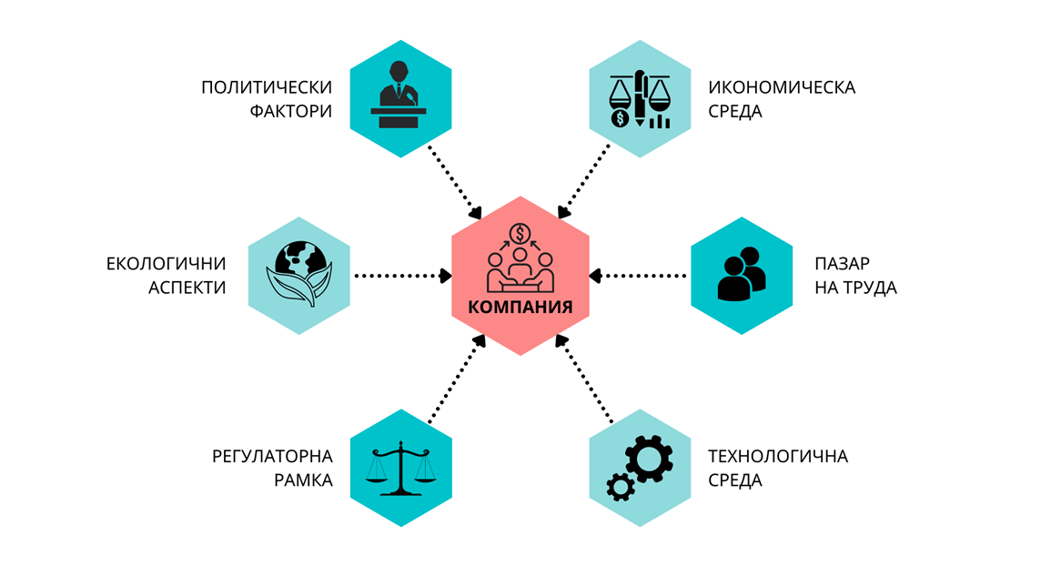
BUSINESS ENVIRONMENT
TECHNOLOGICAL ENVIRONMENT
LABOR MARKET
ECONOMICAL ENVIRONMENT
REGULATORY FRAMEWORK
ENVIRONMENTAL ASPECTS
POLITICAL FACTORS

- EUROPEAN AND NATIONAL POLICY DIMENSIONS
The policies implemented at the European Union level as well as at the national level demonstrate a strong aspiration and incentive for the development of digital technologies and their penetration in all spheres of economic and social life in terms of exploiting their exceptional potential for increasing the competitiveness of the Bulgarian economy, enhancing the supply and efficiency of public services. Digital transformation is a process characterised by the widespread introduction and combination of digital technologies in all spheres of public and economic life. It is a key priority at European level. The pandemic has demonstrated the growing importance of digitisation for all aspects of the economy, society and government. It has also confirmed the need to build high-speed digital connectivity and harness the potential of data by removing barriers to sharing.
The European document outlining the vision and directions for Europe's digital transformation to 2030 - Digital Compass 2030: Europe's path to a digital economy and digital society means solidarity, prosperity and sustainability, underpinned by growing opportunities for European citizens and businesses, while ensuring the security and resilience of the digital ecosystem and supply chains. The Compass is based on an enhanced monitoring system that will track EU developments in terms of the pace of digital transformation, Europe's capacity gaps in the strategic areas of digitisation as well as the implementation of digital principles. It includes the means to achieve the vision and will outline key milestones oriented along four main axes. The first two focus on digital opportunities in infrastructures and in education and skills, while the other two focus on the digital transformation of enterprises and public services.
A population with digital skills and highly skilled digital professionals is one of the priorities set out in the “European Path to the Digital Decade”. Digital skills will be crucial to strengthen our collective resilience, both in times of crisis and to develop the competitiveness of the European market... Basic digital skills for all citizens and the ability to acquire new specialised digital skills for the workforce are a prerequisite for active participation in the Digital Decade. To enable all Europeans to reap the social benefits of an inclusive digital society, and as proposed in the chapter on digital principles, access to education enabling basic digital skills should be a right for all EU citizens and lifelong learning should become a reality. In-depth digital skills do not only require programming skills or a basic knowledge of computer science. Digital training and education for staff should support the acquisition of specialised digital skills by workers in order to find quality jobs and satisfying careers. As of 2019, ICT professionals numbered 7.8 million - an increase of 4.2% from the previous year. If this trend continues, the EU will fall far short of the estimated 20 million professionals needed in key areas such as cyber security or data analytics. More than 70% of businesses cite a lack of employees with the necessary digital skills as a barrier to investment.
Another important priority is Digital Transformation of Enterprises. During the COVID-19 pandemic, the active use of digital technologies became central to many enterprises. By 2030, digital technologies including 5G, the Internet of Things, peripheral computing, artificial intelligence, robotics and augmented reality will be more than enablers, they will be at the core of new products, new manufacturing processes and new business models based on fair data sharing in the data economy. In this context, the swift adoption and implementation of the Commission's proposals for Digital Single Market strategies and building Europe's digital future will support the digital transformation of businesses and ensure a fair and competitive digital economy. The transformation of businesses will depend on their ability to rapidly and ubiquitously adopt new digital technologies, including in industry and service ecosystems that are lagging behind.
The European Path to the Digital Decade identifies construction among the five key sectors where the potential of digital transformation should be unlocked. The main argument is that construction has “the lowest productivity growth among major industries over the last 20 years. 70% of construction executives cite new manufacturing technologies and digitisation as key drivers of change in the industry.”
In this regard, the Bulgarian government adopted a number of strategic documents outlining the vision and objectives of the national policy for digital transformation of the Republic of Bulgaria, as a generalized policy framework, which includes the Digital Transformation of Bulgaria for the period 2020-2030, the National Programme “Digital Bulgaria 2025”, the priorities of the “National Development Program BULGARIA 2030”, as well as a number of other national strategic documents with a technological component covering the period 2020-2030. This framework takes into account the UN 2030 Agenda for Sustainable Development goals and the use of new technologies to achieve them, as well as strategic documents of the European Commission “A Europe fit for the digital age”, “Building Europe's digital future”, “A new industrial strategy for Europe”, etc.
The summarized national policy framework defines the will and vision of the Bulgarian government for digital transformation as a necessary process of technological development in Bulgaria to create conditions for innovation and business growth, increase the efficiency of the workforce, a competitive digital economy and a high standard of citizens.
Driven by our country's strategic goals for accelerated economic development, demographic uplift and reduction of inequalities, set out in the “National Development Programme for Bulgaria 2030”, by 2030 Bulgaria needs to build a functioning and secure environment to unlock the full potential of digital technologies for digital transformation of all key sectors, reaching the European average values of the Digital Economy and Society Index DESI.
The current strategy for digitalization of the construction sector is another step in the process of comprehensive reform of the Bulgarian economy. It is the result of the aspiration of all stakeholders for a comprehensive modernisation of the construction sector, for the digital management of the design, approval, execution and operation of construction processes, for increasing the efficiency of these processes and the competitiveness of the sector, for introducing innovations and improving the qualifications of those employed in the sector, ensuring policies for sustainable construction and managing the built assets in a way that will ensure the realisation of the environmental transition.
The unstable political environment and the frequent changes of governments ruling Bulgaria in recent years have not changed the political vision for digital transformation of the construction sector in Bulgaria. The priorities for reform have been reaffirmed through the National Recovery and Resilience Plan 2022-2026. However, short-term governance periods hinder sustainable investment planning for reform.
The analysis of existing funding strategies and programmes at both national and EU level shows that there are numerous funding opportunities for the digitalisation of construction reform. Although direct support for the digitisation of the construction sector is only specifically described in one of the strategy documents, namely Bulgaria's Digital Transformation 2020-2030, the policies and measures foreseen in the regulatory framework provide opportunities for funding various elements of the strategy and roadmap, such as support for SMEs, for public administrative services, for digitisation of investment projects and for education. An identified challenge is that the envisaged support is spread across different strategies and programmes managed and implemented by different public institutions, which will require close collaboration between the reform leader and the institutions managing the programmes.
Reforming the construction sector also requires a major change in legislation. Several recent governments have committed to revising the regulatory framework, but the short-term period of governance allows for partial amendments that cannot create the necessary preconditions for the full implementation of digital reform.

- CURRENT STATE OF THE ECONOMIC ENVIRONMENT
The construction sector plays an important role in the European economy. It accounts for almost 10% of GDP and 20 million jobs, mainly in micro and small enterprises. Construction is also a major consumer of intermediate products (raw materials, chemicals, electrical and electronic equipment, etc.) and related services. Due to the economic importance of the sector, its efficiency can have a significant impact on the development of the economy as a whole.
The quality of construction also has a direct impact on the quality of life of Europeans. Last but not least, the energy performance of buildings and resource efficiency in the production, transport and use of products for the construction of buildings and infrastructures have a significant impact on energy, climate change and the environment.
The diversity of activities within each branch of the construction sector leads to conflicting facts regarding socio-economic, organisational, cultural and technological issues and adaptation to new regulations and market opportunities.
There are global challenges that can become factors for sustainable growth in the medium term, provided appropriate measures are taken now. This could lead to the development of a range of services to address issues such as health and safety, energy efficiency, green building, disaster resilience, indoor air parameters, reuse/recovery/recycling and design-to-measure. If addressed properly, these challenges could also open up new market opportunities.
The competitiveness of construction companies is therefore an important issue not only for growth and employment in general, but also as a guarantee for the sustainable development of the sector.
The sector can contribute significantly to job creation by increasing its activity in some promising areas such as building renovation and infrastructure, supported, for example, by appropriate policies to stimulate demand but also to encourage investment. In this way, the construction sector has an important role to play in delivering the Europe 2020 strategy for smart, sustainable and inclusive growth. Furthermore, the Commission Communication on an Energy Roadmap 2050 points out that higher energy efficiency in new and existing buildings is a key prerequisite for transforming the EU energy system.
The sustainable development of the construction sector is a crucial factor in achieving the EU's long-term target of 80-95% reduction in greenhouse gas emissions. According to the “Roadmap to a competitive low carbon economy in 2050” , the cost-effective contribution of the construction sector would represent a reduction of approximately 40-50% in 2030 and approximately 90% in 2050. The necessary investments would significantly help the competitiveness of the European construction sector.
The short- and medium-term measures set out in EU policy for the period up to 2030 place even greater emphasis on supporting investments linked to the EU's climate and energy objectives, with a significant share of financial instruments dedicated to investments to support the transition to a low-carbon economy, in particular energy efficiency and renewables, including for the renovation of buildings, as well as investments in technology and the use of flexible working practices. Covid-19 The crisis has affected all economic sectors in Europe, but overall, the construction sector in the EU has suffered less than originally expected in the summer of 2020, when FIEC predicted a fall in investment of 8.5%. Total investment in construction fell by 5.8% in 2020 to €1.4 trillion, equivalent to 10.7% of EU GDP. but differences began to emerge in the summer, with some sectors recovering faster than others. In terms of employment, the sector employed 12.8 million workers in 2020, a slight increase of 0.8% compared to 2019, despite a reduction in hours worked of almost 5%.
In 2021, construction investment was expected to resume growth at a rate of 4.2%. All segments were expected to recover, but investment did not reach the pre-crisis level by 2019. Construction employment declined slightly by 0.1%, with the impact of the crisis felt in late 2021 for some countries.
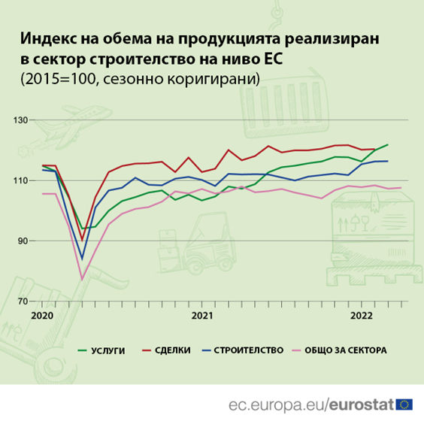
Services Deals Construction Total for the sector
Index of the volume of production realized in the construction sector at the EU level
(2015=100, seasonally adjusted)
In 2020, Bulgaria's GDP will amount to BGN 98.4 billion (EUR 50.2 billion), an increase of 20.2% compared to 2010 and a decrease of 4.2% compared to the previous year 2019. The decline is mainly due to the precautionary measures taken to address the global pandemic of COVID-19.
While the number of enterprises in the broad construction sector (manufacturing, construction, real estate, architectural and engineering activities) increased by 23.2% between 2010 and 2020, the index of manufacturing output decreased by 12.6% between 2015 and 2020. This is mainly due to recorded declines of 21.8% in infrastructure construction and 5.2% in building construction during the reporting period, reflecting the macroeconomic trend.
The total turnover of the broad construction sector in Bulgaria amounted to EUR 11.8 billion in 2018, marking an increase of 18.9% compared to 2010 (EUR 9.9 billion). The further increase in turnover to €14.3 billion in 2020 represents a 44.2% increase since 2010. This overall increase is due to growth in the sub-sectors: manufacturing (+62.5%), real estate activities (47.8%), construction (+44.0%) and architectural and engineering activities (+8.0%), for the period 2010-2020.
In terms of employment, the Bulgarian broad construction sector employed 293,347 people in 2020, an increase of 6.3% from 2010. This is due to growth in the sub-sectors in terms of persons employed: real estate activities (+14.3%), construction (+6.7%) and architectural and engineering activities (+0.9%) between 2010 and 2020.
There are several significant problems hindering the sustainable development of the Bulgarian construction sector. The first is the increasing number of bankruptcies declared by companies in the broader construction sector. The number of company closures in the real estate, architectural and engineering and construction sub-sectors grew significantly by 810.8%, 459.8% and 164.9% respectively over the period 2010-2018.
Second, the problem of late payments by customers is also prevalent in the sector. The outbreak of the COVID-19 pandemic has made the situation even more difficult. According to the Atradius Payment Practices Barometer, 76.0% of Bulgarian respondents report that payment delays in 2020 will average 30 days. This is the longest payment period of all countries in Eastern Europe. According to the European Payments Report 2021, around half of SME respondents (47.0%) believe that late payment issues have significantly hindered investment in strategic growth initiatives.
Third, the growing shortage of skilled and professional labour in the construction sector continues to be a major problem. The number of vacancies in the construction sub-sector reached a new peak of 937 in 2020, representing a significant increase of 598.1% from the 2010 level of 134 vacancies. Interest in the construction and engineering sector is on a downward trend. The number of engineering students has declined by 29.2% between 2010 and 2019, with the largest declines in engineering and manufacturing students (-35.3%), and those with a major in architecture and civil engineering (-33.9%). Bulgarian businesses face difficulties in finding a qualified workforce. The problem is expected to grow as the working age population in Bulgaria is projected to decline from 64.0% in 2020 to 55.7% in 2050.
According to the 2020 World Bank's Doing Business Report, Bulgaria ranks 43rd out of 190 in 2020 in terms of “dealing with construction permits”, maintaining its place from last year's ranking. According to the report, it takes 18 procedures to obtain a building permit in Bulgaria, compared to 12.7 in high-income Organisation for Economic Co-operation and Development (OECD) countries. The cost of obtaining a building permit in Bulgaria is also higher than the OECD average at 3.4% of the material value of the construction (warehouse), compared to 1.5% in the OECD. Conversely, Bulgaria performs better than the OECD average in terms of the time taken to obtain a building permit. Bulgaria takes 97 days to obtain a building permit, compared to 152.3 days in OECD countries.
Bulgaria's housing market grew significantly in 2020 despite the challenges stemming from the COVID-19 pandemic, with residential property prices continuing to rise, albeit at a slower pace compared to the pre-crisis period. In fact, the house price index rose by 37.4% in 2020 compared to 2015, with the index for existing homes and new homes increasing by 40.0% and 33.0% respectively. The market has been supported mainly by rising demand for housing, fuelled by the continued decline in interest rates.
The trend of steady growth has accelerated with the post-pandemic recovery: house price growth increased to 9.1% y-o-y in the second quarter, up from 7.5% y-o-y in the first quarter, according to the National Institute of Statistics. Both investors and households are favouring housing as an investment as deposit interest rates are falling.
In its €6.5 billion Recovery and Sustainability Plan, Bulgaria has earmarked €947.0 million for energy efficiency initiatives, including renovation. These measures target multi-family residential buildings, state and municipal buildings, industrial and commercial buildings.
The plan offers a special programme to finance stand-alone energy efficiency measures for houses, such as the purchase of energy efficient heat pumps, solar domestic heating systems and photovoltaic systems in buildings not connected to the heat and gas networks.
In terms of investments in infrastructure construction, Bulgaria plans to invest around BGN 6.5 billion (EUR 3.3 billion) in the construction of railway infrastructure on its territory jointly with the EU. The Convergence Programme of Bulgaria (2021-2023) proposes an increase in the subsidy by BGN 50.0 million (EUR 25.5 million), 0.04% of the projected GDP, for the ongoing maintenance and operation of the railway infrastructure in 2021. In addition, Bulgaria has earmarked around BGN 1 309.2 million (EUR 667.7 million) for the digitisation of its rail transport by upgrading safety and energy efficiency systems on the rail lines of the TEN-T core and comprehensive network.
These measures would contribute to economic recovery and benefit the construction sector.
The outbreak of the COVID-19 pandemic significantly affected the economic landscape of the country. In July 2021, the interim government proposed to amend the 2021 fiscal budget and use the surplus revenue to increase state pensions and prepare the country for another upsurge of the COVID-1910 pandemic. This in turn will impact potential growth opportunities, including the construction sector. It is expected that government measures, even if not directly targeted at the construction sector, will benefit it as well as its economic operators.
The overall outlook for the Bulgarian broad construction sector is promising in the long term. The optimistic outlook is based on increasing investment in public infrastructure supported by EU funding.
After a decline of 4.2% in 2020, the Bulgarian economy grows by 3.5% in 2021, mainly driven by private consumption and investment.
Moreover, the country's economy is expected to grow by an additional 4.7% in 2022, reaching its pre-crisis level (2019 level, pre-COVID-19) of real output, totaling 106.6 billion leva (54.4 billion euros) in 2022.
Similarly, the output volume index in the broad construction sector grew by 4.7 ip in 2021. This was primarily driven by growth in the building construction and infrastructure sub-sectors of 6.0 ip and 4.0 ip in 2021. In 2022, the output volume index of the broad construction sector is expected to grow further at an annual rate of 7.3 ip in 2022, driven by growth in infrastructure construction (+8.0 ip) and building construction (+6.0 ip), indicating that growth in the sector will accelerate in 2022.
In the context of the housing market, the country's positive economic outlook, coupled with low interest rates on home loans, is expected to stimulate demand for housing. The latter will also be fuelled by increased savings and zero interest rates on deposits, which in turn may increase speculative investment in housing and lead to higher house prices.

- PROFILE OF EMPLOYEES IN THE CONSTRUCTION SECTOR
The construction sector includes the construction of commercial, industrial and residential buildings and engineering projects such as roads, bridges and utility systems. Construction includes new construction as well as remodeling, maintenance and repair work. Businesses and self-employed individuals in this industry may work independently or as subcontractors. They may be responsible for large projects from start to finish, or they may work on a specific stage of the project. Enterprise activities are usually managed at a specific location, but the actual construction activities at different locations. Positions vary, from unskilled laborers and helpers to skilled employees who require professional training and education.
Employment in the construction sector amounts to 267.9 thousand or 8.7% of the country's employed persons, of which 121.9 thousand persons are employed on an employment and service relationship at the end of September 2022. The private sector employs 98.2% of the sector's employees. In addition, a significant number of construction workers are employed in the informal economy, the number of which is not captured in official statistics.
The average annual salary in the sector is BGN 15 132 per year (BGN 1 261 per month), which is about 74.5% of the national average. Compared to 2021, average annual wage growth in the sector is 10.5% and lags around 2.2 percentage points behind national average wage growth.
Observations from nearly 40.5% of employers in the sector indicate that turnover has been on the rise in recent years. At the same time, 66.2% of employers report an increase in labor turnover in their establishments due to downsizing and/or upsizing. Some specific characteristics of the sector include:
- The construction industry contributes strongly to economic growth;
- Wages in the sector are below the national average;
- In the sector, workers are predominantly male, in the middle and higher age groups with secondary and vocational education. Women are mainly employed in administration.
- Part-time work is relatively uncommon in construction, which may partly affect women's participation in the workforce.
- There is relatively high self-employment in construction compared to other sectors of the economy
Based on information from the employees and employers surveyed in the sector, the profile of employees is shown in the following table
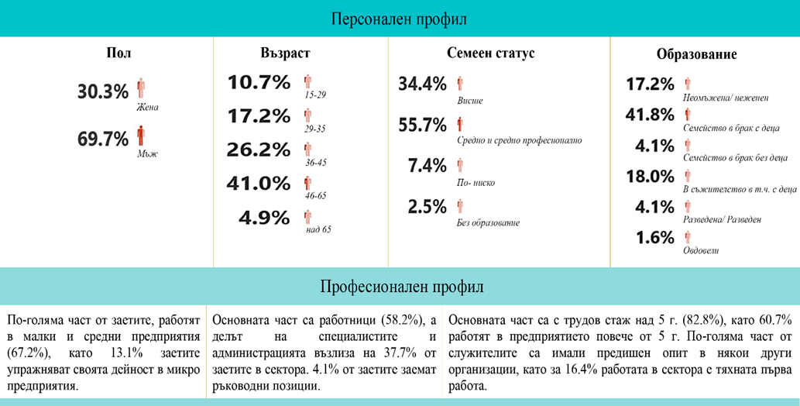
Professional Profile
Most of the employed work in small and medium-sized enterprises (67.2%), with 13.1% of the employed working in micro-enterprises.
The main part are workers (58.2%), and the share of specialists and administration amounts to 37.7% of those employed in the sector. 4.1% of the employed hold managerial positions.
The main part have more than 5 years of work experience (82.8%), with 60.7% working in the enterprise for more than 5 years. A larger part of the employees had previous experience in some other organizations, and for 16.4% the work in the sector is theirs first job.
High
Secondary / secondary vocational
Lower
No education
Unmarried
Married family with children
Married family without children
In cohabitation, including with children
Divorced
Widowed
MARITAL STATUS
EDUCATION
Man
Woman
AGE
SEX
PERSONAL PROFILE
Employees in the sector do physically demanding work that can be somewhat restrictive in terms of the age up to which workers can exercise.
The sector is characterised by significant health and occupational hazards that place serious demands on working conditions and employee safety.
Employee attitudes to job hopping is high (21% of employees). The highest proportion of workers (65.4%) and professionals (27.1%) are inclined to look for another suitable job. A characteristic feature is the high share of employees (42.3%) with more than 5 years of work experience in the enterprise who would consider such an alternative.
The highest attitudes for voluntary resignation are expressed by employees of enterprises operating in the districts of Sofia-city (38.5%), Gabrovo (15.4%), Plovdiv (11.5%), Kyustendil, Silistra and Shumen - 7.7%.

In terms of turnover caused by involuntary redundancies, it shows that a significant proportion of employers have resorted to such measures. The main factors leading to redundancies in the sector are set out below:

Relative share of employers resorted to forced termination of employment in the last three years -58.1%.
Reasons for involuntary termination of employment
Due to failure to perform assigned tasks | 54%
Unprofessional attitude and weak commitment to company goals | 45%
Lack of adequate professional training | 31%
Dismissal or discharge due to cases of workplace conflicts | 26%
Due to the deterioration of the economic situation and the inevitable closure/redundancy of jobs in the company | 23%

The following chart shows the main characteristics of the profile of employees in the construction sector who are likely to leave in an attempt to find another suitable job
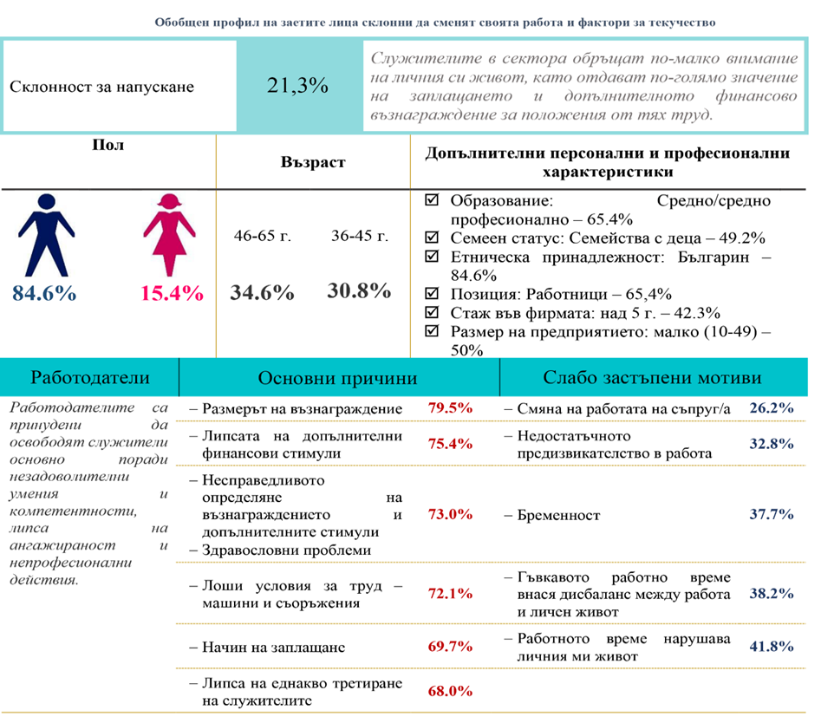
- Change of spouse's job
- Insufficient challenge in work
- Pregnancy
- Flexible working hours introduce an imbalance between work and personal life
- Working hours disturb my personal life
- The amount of remuneration
- The lack of additional financial incentives
- Unfair determination of remuneration and additional incentives
- Health reasons
- Bad working conditions - machines and equipment
- Method of payment
- Lack of equal treatment of employees
Employers are forced to release employees mainly due to unsatisfactory competences, lack of commitment and unprofessional actions
Employers Main reasons Low-represented reasons
Education: Secondary / secondary vocational - 65.4%
Family status: Families with children - 49.2%
Ethnicity: Bulgarian - 84.6%
Position: Workers - 65.4%
Experience in the company: over 5 years - 42.3%
Enterprise size: small (10-49)-50%
A summary profile of employed persons who tend to change their job and turnover factors

Tendency to leave | 21.3% | Employees in the sector pay less attention to their personal lives, giving more importance to pay and additional financial remuneration for the work they do.
Sex | Age | Additional personal and professional characteristics

Education and professional qualifications
Bulgaria has one of the lowest public spending on education among EU member states, accounting for 3.9% of GDP (below the EU-27 average of 4.7%). The country continues to face challenges in improving digital skills, reducing school drop-out rates, increasing staff salaries and strengthening inclusive learning.
The number of students in Vocational Education and Training (VET) increased to 52.9% in 2018, above the EU-27 average of 48.4%. The employment rate of recent VET graduates also increased significantly in 2019 to 73.5% from 66.4% the previous year, although it remains below the EU27 average of 79.1%.
According to data for 2021 from the Rating System of Higher Education Institutions in the Republic of Bulgaria, 4887 students are studying in the professional field of Architecture, Civil Engineering and Geodesy. The average secondary school diploma grade is relatively high - a very good 5.07 - which means that candidates with high potential are being attracted to the sector's professions. The unemployment rate among graduates is 2.18% and the vocational realization rate is 67.29%. The average social security income of graduates is BGN 1 499.
According to the medium- and long-term forecasts for the development of the labour market in Bulgaria, published by the Ministry of Labour and Social Policy, the demand for human resources in the construction sector will increase by about 4.7% in the period 2020-2034. The sector is expected to employ 178 868 persons with secondary education (more than 8300 persons more than in 2020), 26 381 persons with primary and lower education (more than 1200 persons more than in 2020) and 48 828 persons with higher education" (more than 2300 persons more than in 2020).
However, there are several challenges regarding VET that need to be addressed, including its underfunding, poor cooperation with the business sector, increasing drop-out rates, outdated curriculum, shortage of qualified teachers and lack of a coherent evaluation system for the VET system.
In a context where 17.5% of the working age population (25-64 years) is low skilled, upskilling and reskilling the population remains a significant challenge in the context of the economic recovery from COVID-19. The National Development Agenda 2030, approved in January 2020, sets a target of 7.0% participation in education and training by 2030.
According to the recent Labour Force Survey, only 2.0% of adults aged 25-64 in Bulgaria had learning experience in the previous four weeks.
Bulgaria continues to have one of the lowest levels of digital skills among the young population in the EU. Only 57.0% of the population aged 16-19 has their level of digital skills assessed as basic or above, compared to the EU27 average of 82.0%. Furthermore, the country ranks at the bottom of European rankings based on the level of digital skills of adults, young people and ICT professionals in the 2020 Digital Economy and Society Index. However, in recent years there has been an increasing focus on improving digital skills and digital education.
As part of its NRRP, Bulgaria has allocated around €800 million to the Education and Skills programme. With this investment, the country aims to improve e-learning, support the deployment of digital technologies and improve educational infrastructure to digitise it.
In many Member States, construction companies are faced with labour shortages and/or workers who do not have the necessary technical skills for the sector. This is due to the fact that the industry is characterised by a large and heterogeneous number of professional competences that are undergoing a rapid transformation due to the greening and digitisation of the sector.
On the one hand, this situation creates an opportunity to attract and retain young people with digital skills, but at the same time the current workforce is ageing and a number of workers need to be retrained.
Although vocational training and education is a national competence, a number of European programmes, including FIEC provide support for cooperation and exchange of best practice between Member States. A skilled workforce is a prerequisite for the transition and ensures a future sustainable competitive digital economy. The European Agenda on Skills for Sustainable Competitiveness, Social Equity and Sustainability is also relevant for the construction sector. It sets ambitious, quantitative targets for skills to be achieved over the next 5 years. The actions envisaged focus on skills for work, including green and digital skills, by partnering with Member States, companies and social partners to work together for change, by encouraging people to embark on lifelong learning and by using the EU budget as a catalyst to unlock public and private investment in people's skills.

Readiness of industry stakeholders to implement BIM
The readiness of construction industry stakeholders to implement BIM can be positioned at BIM level 0, with some progress at BIM level 1.
The majority of the Bulgarian construction industry has no or limited experience with BIM. SMEs mostly apply traditional project management workflows involving 2D drawings in their practices and have adopted a silo-oriented approach. BIM technologies are typically used at the design stage, less so at the construction stage, and do not reach the later stages of the construction lifecycle. Progress in this respect has been hampered by the divergent interests of those involved in the investment and construction process. Mainly planners, and architects in particular, have more experience with BIM. There are some gaps in the readiness of engineers for SIM compared to that of architects who are better positioned in this respect. Although there are businesses that use CAD - 3D or 2D with some common features in the data environment, the construction industry is generally not experienced in collaboration between parties that collect information on a built asset.
In the few cases of BIM use, there are uses related primarily to 3D modeling, generation of drawings, documentation, bill of quantities, and visualization. The main drivers for business adoption of BIM include: increased competitiveness; internal optimisation; entry into new markets and customer requirements. The biggest advantages of SIM, as seen from the views of stakeholders who have relevant experience, relate to: reduced errors; easier coordination with other actors; faster and more efficient documentation generation; better project management, execution and control; improved competitiveness and reputation.
It should be noted that there is a pressing need to raise awareness of the return on investment in BIM for each of the different groups involved in the construction process, according to their interests and expected benefits.
The main difficulties that stakeholders encounter in implementing BIM relate mainly to: the high cost of software and hardware; lack of implementation of BIM by other actors in the process; gaining in-house expertise; lack of training literature, guidelines and template documents; and inconsistencies of BIM software with local standards. Other barriers identified include: software not available in local language; legal barriers; interoperability issues between different SIM software and/or other software. In order to start using BIM, stakeholders need to invest in staff training, software that supports BIM, development of internal workflows for SIM, development of joint BIM processes with external parties, solutions for specific software/interoperability upgrades, new/upgraded hardware.
Stakeholders believe that more industry participants will begin to use BIM as a result of increased customer demand. In this regard, it is evident that stakeholders expect a government push towards digitisation, which includes digitisation of administrative procedures related to construction document approvals, building permits, archiving and storage, upgraded with requirements to use BIM.
For those who have not yet implemented BIM in their work, the main barriers relate to: lack of readiness from other actors in the process; budget constraints; lack of demand; insufficient information and training; lack of internal expertise; lack of support from the state. The incentive for this group to introduce BIM will be the availability of affordable training, information and appropriate educational programmes, as well as increased demand from their customers. It also requires the definition of a national standard BIM framework and the removal of administrative and regulatory barriers to its implementation. A focus on BIM training in administration, academia and vocational schools is needed, as well as targeted government funding to create a publicly accessible platform, training for businesses, and information on BIM regulatory requirements.
Industry stakeholders demonstrate different attitudes towards the wider implementation of BIM at national level, in particular with regard to the sequencing of actions required. On the one hand, some stakeholders strongly support the idea of significant progress in the digitisation of public administration and the design process before the introduction of BIM through state reform initiatives. Others believe that the mere implementation of the BIM will pave the way for the digitisation of the construction sector. On the other side of the spectrum are those who believe that the digitisation of the construction sector has nothing to do with the operation of BIM. However, they all share the common view that the phased adoption of BIM can be planned in parallel with government action to establish mandatory administrative requirements, digital public administration and e-administration of the construction process.

Readiness of public administration to implement BIM
The Public Administration is holding discussions and developing draft amendments to the Land Development Act (LDA) that provide for advances in the digital construction process. The MRDPW has developed and is implementing a number of new projects in the field of digitalisation. These projects foresee the creation of a single public register and a unified information system for spatial planning, investment design and construction permitting, the creation of a spatial planning portal, including cadastral map upgrades and the provision of planning data.
In terms of BIM implementation, the needs in the public sector are mainly related to basic and continuous training, provision of software and hardware, and the availability of BIM manuals and protocols.
Local municipal administrations are more familiar with BIM than central administrations, but the principles and methodologies of BIM have not been presented to them in depth, nor have they been tested in practice. There are some good examples of municipalities that have a better awareness of BIM, but they are the exception among the 265 municipalities in Bulgaria. The more digitally innovative local administrations implementing smart city strategies are more aware of BIM, mainly because of their progress in digital transformation.
The public sector is not prepared to procure design and construction works through BIM. No templates have been developed for procurement documents that require the use of BIM and no incentives have been applied by contracting authorities in this respect. The main reasons for the lack of practice with BIM in public procurement include: lack of a general policy to stimulate digital construction and lack of a clear definition of BIM, standards, accompanying manuals, templates and guidelines.
In general, the public sector is less familiar with BIM than the private sector. It lacks theoretical and practical knowledge and experience with BIM. Even those who have some knowledge of BIM are not aware of its technical aspects, its application in construction and most importantly the benefits it can bring to public investors and society at large. However, some good examples can be found at municipal level.
The main barriers to the introduction of BIM identified by public administrations include: lack of sufficient information on the digitisation of the whole construction process; reluctance of civil servants to transform their work processes into modern digital practices; lack of unified formats for digital design and electronic submission of projects; lack of qualified staff and limited recruitment opportunities due to low remuneration levels; lack of centralised systems for information exchange in a Common Data Environment (CDE); high administrative burden; lack of electronic systems for administrative services in the construction sector; lack of electronic cadastral maps and availability of only a few GIS systems.

- TECHNOLOGICAL ENVIRONMENT
Innovation in construction
According to the European Innovation Scoreboard 2021, Bulgaria is an emerging innovator. Bulgaria's top performers include environmental technology development, design applications and brand applications. The country's strongest innovation dimensions are environmental sustainability and employment impact. Bulgaria scores above the average share of non.innovators with no propensity to innovate and has lower scores on climate change related indicators.
Business enterprise research and development (BERD) expenditure in the construction sector increased by 872.9%, from €0.2 million in 2012 to €1.8 million in 2018. In professional, scientific and technical activities, BERD increased by 44.4%, from €6.8 million in 2012 to €9.8 million in 2018. The average annual number of patent applications related to construction remained stable at 2 pc over the period 2010-2019.
In parallel, total R&D staff (full-time equivalent - FTE) has increased strongly. In the construction sub-sector, it rose from 7 in 2012 to 149 in 2018. FTEs in researchers also increased from 5 in 2013 to 80 in 2018. The professional, scientific and technical activities subsector also reported strong increases over the 2012-2018 period in terms of FTEs, amounting to 312 and 198, respectively.

Eco-innovation and digitalisation
According to the Eco-Innovation Index for 2021 (Eco-IS), Bulgaria scored 50, which is well below the EU-27 average of 121. According to the report, Bulgaria is among the lowest performing EU Member States in the 2021 Eco-Innovation Index and is in the category of “Catching up on eco-innovation”.
In the context of resource efficiency scores, the country ranked last among EU Member States with 17 points, significantly below the EU27 average of 147.
Bulgaria faces several challenges in terms of increasing investment opportunities in eco-innovation and the circular economy, promoting resource efficiency by increasing energy efficiency, developing renewable energy sources and improving sustainability practices in the transport sector. Factors such as low levels of investment in research and innovation (R&I), a fragmented public science base, a lack and ageing of skilled human resources and ineffective governance continue to hamper Bulgaria's productivity and economic growth potential.
According to the Digital Economy and Society Index (DESI) 2022, Bulgaria ranks 26th with a score of 37.74, compared to the EU-27 average of 52.3. Bulgaria's DESI score has increased by an average of 9% per year over the last five years. Bulgaria scores very well in the area of Connectivity and is ranked 19th with a score of 50.7 against the EU27 average of 59.9. In 2021, Bulgaria exceeded the EU average in both coverage of high-speed next generation broadband (93% vs. 90% in the EU) and coverage of very high-capacity fixed networks (HCFN) (85% vs. 70% in the EU). However, the key indicators have not improved enough to keep pace with the EU27 average. The level of digital skills in Bulgaria is one of the lowest in the EU region. In terms of digital inclusion, Bulgaria's performance is also well below the EU27 average.
According to the SME Country Fact Sheet 2021, only 50.0% of small companies in Bulgaria have a website and only 7.2% of SMEs sell online, compared to the EU27 average of 76.0% and 17.0% respectively. Furthermore, only 3.0% of SMEs sell cross-border, with only 2.0% of their turnover coming from the online segment.
In December 2019, the Bulgarian government introduced the national programme “Digital Bulgaria 2025”. It sets out the country's ambitions to modernise and widely deploy smart IT solutions in all areas of the economy, including construction. The programme focuses on improving digital competencies and skills by supporting ICT research and innovation, modernising school and higher ICT education, increasing the number of highly skilled ICT professionals and improving the digital skills of the workforce.
In 2021, two national programmes were adopted in the higher education system –“Improving the competences of public higher education teachers preparing future teachers” and “Digital qualification”. The first national programme for higher education institutions provides direct funding for the construction of training centres and for equipping halls for the use of innovative educational technologies in the training of students.
The second national programme – “Digital Qualification” - will train current and future teachers of subjects and modules related to digital work, as well as business representatives who want to start teaching, over a three-year period. The main objective is to prepare, through additional training, staff who can teach ICT and digital subjects at different levels of the education system. Teachers of different subjects in the secondary education system will also be trained to enable them to retrain as IT teachers. The programme also foresees the creation of a platform for the exchange of good practices.
Another measure is the commitment of the rectors of public higher education institutions to provide adequate conditions for learning and assessment in an electronic environment, interdisciplinary integration of different aspects of digital technologies in the teaching and learning process. Higher education institutions are also implementing various activities related to virtual reality and artificial intelligence, including the creation of specialized structures within a given institution where students are not only trained but also prepared for professional realization in the conditions of modern requirements and trends in the labor market.
The Ministry of Transport and Communications has endorsed “Bulgaria's Digital Transformation 2020-2030”, covering the potential of digital transformation for growth, jobs, health, energy policy, social participation and government transparency. The Government has initiated various forms to improve and boost its innovation system, such as the implementation of the Operational Programme “Science and Education for Smart Growth 2014-2020” and the strategy “Better Science for a Better Bulgaria 2025”.
According to EIB Group's Investment and Investment Finance 2020 survey for Bulgaria, 55.0% of firms have implemented, fully or partially, at least one of the digital technologies in 2020, below the EU27 average (63.0%). According to the report, around 17.0% of construction firms have adopted Internet of Things in 2020, drones and 3-D printing were adopted by 12.0% and 8.0% of Bulgarian construction firms in 2020 respectively. Only 2.0% of construction firms have adopted Augmented or virtual reality.
Bulgaria has also introduced the Digital Transformation of Bulgarian Industry - Industry 4.0 strategy to promote and accelerate the digitalisation process. Private companies have started to educate the Bulgarian construction industry on the benefits of using building information modelling by organising various events.
Bulgaria is still lagging behind most European countries when it comes to BIM adoption. There is a need to create more public interest in the use of BIM. To address this problem, the government has prepared this strategy as well as a number of projects to support digitisation in investment design and construction.

Development of BIM in Bulgaria
Since 2013, various initiatives related to BIM have been undertaken in Bulgaria. In general, since 2017, more intensive activities have been observed for the application of BIM in the private sector. These include: surveys among planners, architects and engineers on the awareness and use of BIM; conferences and workshops; signing of a memorandum on the application of BIM among architects, engineers and builders (the AEB community); research and publications by academic authors.
The key industry chambers, the Chamber of Bulgarian Builders (CCB), the Chamber of Engineers in Investment Design (CEID) and the Chamber of Architects in Bulgaria (CAB), have made efforts to develop policies for the implementation of BIM on their own, but so far the initiatives of these organizations have been hampered, mainly due to the lack of common interest and concerns of different nature. The Bulgarian Society of Construction Law (BSCL) organisation has produced an English language version and Annex 6 Part 1 “Legal Requirements” of the 2016 English edition of FAC-1, which is a universal standard form for a collaborative framework agreement to assist in obtaining increased value through the implementation of BIM.
The teaching of BIM in higher education is not sufficiently popular or explicitly the focus of academic programmes. The disciplines and curricula focused on BIM are mainly oriented towards design majors. A significant amount of practical BIM training is conducted by private training centres or by BIM software distributors, with the focus of the training being on the 3D modelling/coordination aspects rather than on information management and collaboration.
Several Bulgarian IT companies operate in the sector and develop software for construction, including in Bulgarian. However, their products are either not fully in the BIM framework or are not available on the Bulgarian market due to the limited demand for BIM software. There are a number of private investment projects related to the introduction of BIM that are supported by innovation funding programmes, but, overall, the number of construction projects in Bulgaria designed using BIM remains limited. All these projects have been awarded by foreign contracting authorities from the US and the EU, which have already gained good experience with BIM. However, there are a number of good examples of projects in the country that have been implemented in a BIM environment, mainly by local design offices and architects.
In 2017, representatives from 23 EU Member States developed a Guide to the Implementation of BIM by the European Public Sector. The Handbook was prepared in the framework of the EU BIM Implementation Working Group, in which there are no representatives of Bulgarian authorities or institutions. As of 2019, the MRDPW already has a national representative in this working group at EU level. In February 2020, the MRDPW established a National Working Group on BIM with the main task of developing a long-term strategy and roadmap for the implementation of BIM in the design, execution and maintenance phases of construction as a basis for the digital transformation of the construction sector.
In general, Bulgaria has been relatively but not sufficiently active in its path towards the introduction of BIM in recent years. Efforts have been made to raise awareness among stakeholders and to create an environment for wider implementation of BIM. BIM is gradually starting to be seen as the core of the digital progress of the construction industry.
- REGULATORY FRAMEWORK
The main normative act that regulates the public relations related to the spatial planning, investment design and construction in the Republic of Bulgaria is the Spatial Planning Act. It does not hinder the digitisation of the design, approval, construction and operation of construction processes, as it requires the development and submission for approval of spatial plans and investment projects to be carried out both on paper and electronically. The law also provides for the establishment and maintenance of a Unified Public Register of Spatial Planning and the publication of issued acts and draft plans on the websites of state, regional and municipal administrations.
The introduction of BIM is foreseen in European legislation - the 2014 EU Public Procurement Directive), which creates the conditions for MS to be able to require the use of specific electronic tools, such as electronic modelling tools for works information in public works tenders and design competitions. The Directive has been transposed into national law and the Public Procurement Act creates the conditions for requiring BIM technologies in the execution of public design and construction contracts.
What really hinders the implementation of digital options for the transmission of plans and investment projects is the lack of a regulatory framework that defines formats and standards for their development and approval in digital form, as well as IT infrastructure through which public administrations can accept and communicate the approval of plans and projects, issue the necessary permits and maintain the relevant registers and databases with them. The requirements for signatures and stamps on construction documentation predetermine its paper-based format.
Providing administrative services under the Spatial Planning Act electronically is a serious challenge. It will ensure the possibility of carrying out the processes of spatial planning, investment design and construction in electronic mode, will lead to the unification of practices in the application of legal provisions, reducing the time for the performance of certain services, facilitating the process of administrative services and reducing costs for citizens and businesses, as well as for the administration itself, setting a uniform standard in the way of preparation and submission of documentation, better control over the quality of developments, reducing the volume of paper documentation and structuring the entire process in a single system with certain action procedures.
In connection with the establishment of a Unified Public Register on spatial planning, a measure is envisaged “Analysis of the regulatory framework, the current state of the maintained registers and the work processes in connection with the establishment of a unified public register on spatial planning, investment design and construction permitting and an information system for its service”. The activity will include a review and comprehensive analysis of the existing legislation in the field of spatial planning, investment design and construction permitting. It will identify all provisions that provide for the provision of documents certifying information and data for entry in the single register. Following the analysis, draft amendments and supplements to the applicable legal acts providing for the use of data from the register for the purpose of providing administrative services (including in relation to the support of administrations for the provision of complex administrative services) will be prepared, with the relevant justification and a draft impact assessment of the draft legal acts. An Ordinance on the procedure for keeping a single public register on spatial planning, investment design and construction permitting will be drawn up and adopted, which will regulate the functioning of the register.
In connection with the establishment of the Unified Information System on spatial planning, investment design and construction permitting, the measure “Preparation of draft amendments to related legal and regulatory acts, including the establishment of a by-law for the operation of the Unified Information System on spatial planning, investment design and construction permitting” is envisaged.
The activity will review the regulatory framework and the current status of the work processes related to the establishment and functioning of a unified information system for spatial planning, investment design and construction permitting. It will identify the legal acts that should be changed in order to regulate the functioning of the system and to what extent they should be amended. Draft amendments will be made to the following legislation:
- regulating the way services are provided electronically;
- regulating a uniform format for the submission of draft spatial plans and investment projects;
- electronic signature;
- inter-ministerial coordination and issuance of the necessary acts under the special laws;
- the provision of baseline data/visions for design;
- coordination with operating companies;
- deadlines;
- a transition period to go fully electronic.
A sub-legislative act will be drafted, defining the procedure and requirements for the operation and functioning of the unified information system on spatial planning, investment design and construction permitting.
The introduction of BIM also provides for the analysis and development of a legislative framework. For its operation, the legal framework needs to regulate:
- electronic document management workflows;
- digital project documentation, formats, storage and management in specific formats in accordance with defined standards;
- collaboration and digital project review;
- digital submission and permit document formats;
- BIM capacity assessment requirements as part of procurement procedures;
- incorporating CAD standards and digital document procedures within public procurement;
- the ability to submit digital technical bids within approved formats in accordance with established standards and protocols;
- automated workflows for facility design verification, permitting;
- electronic signatures and approval for the scope of the project;
- digital archiving, procedure, storage requirements and encoding protocols;
- data requests in a common environment for hosting BIM projects in a specific format;
- integration of BIM projects with GIS and the environment around the facility;
- project compliance regulations;
- digital transmission, digital warranties, certification and maintenance of post-construction functions and other specifics related to the digitization of documents;
To implement these requirements, the following regulations should be analysed, supplemented or substantially revised:
- Spatial Planning Act;
- Ordinance No. 2 of 31 July 2003 on the commissioning of construction works in the Republic of Bulgaria and minimum warranty periods for completed construction and assembly works, facilities and construction objects;
- Ordinance No. 3 of 31 July 2003 on drawing up acts and protocols during construction;
- Ordinance No. 4 of 21 May 2001 on the scope and content of investment projects;
- Ordinance No. 5 of 28 December 2006 on the technical passports of buildings;
- Ordinance on the conditions and procedure for compulsory insurance in design and construction, adopted by Resolution No. 38 of the Council of Ministers of 24.02.2004;
- Ordinance No. 7 of 22 December 2003 on rules and regulations for the development of individual types of territories and spatial development zones;
- Ordinance No. 8 of 14 June 2001 on the scope and content of development plans;
- Ordinance No. rd-02-20-25 of 3 December 2012 on the conditions and procedure for issuing a certificate for entry in the register of consultants for conformity assessment of investment projects and/or construction supervision;
- Ordinance No. rd-02-20-1 of 5 February 2015 on the conditions and procedure for the use of construction products in construction works in the Republic of Bulgaria;
- Public Procurement Act;
- Copyright and Related Rights Act.
In accordance with the European and international standard BDS EN ISO 19650 “Organisation and digitisation of information on buildings and civil engineering structures, including Building Information Modelling (BIM). Information Management using Building Information Modelling”, a set of documents and protocols should be developed as part of the BIM adoption policy:
- Process mapping, including the necessary adaptation to the requirements of the Bulgarian public sector, including the different ministries and municipalities
- Model Public Sector Employer Information Requirements (EIR) document - this will set out the requirements for the information and documentation that digital BIM Level 2 projects must contain. This document will become an integral part of the tender documents and specifications for public projects, and will be an important part of the contract of employment for all contractors and subcontractors involved in the construction activities of the public project.
- BIM and Digital Capacity Assessment Questionnaire: This questionnaire must be completed by each participant in each procurement activity awarded a BIM. The purpose of the assessment is to measure and ensure the adequacy of the participant's capabilities to perform its role in the BIM project. The Bidder shall ensure that it has all the necessary resources, knowledge, technical skills, software, hardware and IT infrastructure to enable it to operate the Level 2 SIM and meet all the technical requirements presented in the EIR and BEP (BIM Implementation Plan).
- BEP (BIM Implementation Plan) template: in which the bidders shall submit a plan for the execution of the SIM requirements, the project execution specifications and the relevant information requirements related to its scope of work. One of the key components for successful implementation of BIM is having a strong and effective BIM Implementation Plan.
The reform of the construction sector requires a serious review and revision of the regulatory framework governing the processes of design, approval, storage and use of construction documentation during the execution, operation and demolition of construction works. The necessary changes are foreseen in the current strategy and in the planned project investments by the MRDPW. However, the short-term period of governance of the last governments allows only partial amendments to individual acts, which cannot create the necessary preconditions for the full implementation of the digital reform.

- ENVIRONMENTAL ASPECTS
Waste management
Over the years, waste generated from construction and demolition activities in Bulgaria has increased significantly, from 27 109 tonnes in 2010 to 73 731 tonnes in 2018. Construction waste represents 0.1% of the total national waste generation according to SMART WASTE partners.
In terms of waste recycling, Bulgaria's municipal waste recycling rate was 31.5% in 2018, below the EU-27 average of 47.2%.
Although municipal waste production is at one of the lowest levels in the region, waste management remains a challenge for Bulgaria. The country maintains one of the highest municipal waste disposal rates in the EU. In March 2020, the European Commission approved a €77.0 million investment from the European Regional Development Fund to upgrade Sofia's integrated waste management system. The overall objective is to build a highly efficient plant for the simultaneous production of heat and electricity using fuel derived from non-recyclable municipal waste.
Climate and Energy
Emissions of greenhouse gases (carbon dioxide, nitrous oxides and methane) and air pollutants (carbon monoxide, nitrogen oxides and particulate matter) from activities in the construction and real estate subsectors amount to 625 922 tonnes and 20 795 tonnes, respectively, in 2019. Emissions from activities in the construction sub-sector recorded an increase of 13.3% in 2019 from the 2010 level (552 356 tonnes), while the real estate activities sub-sector recorded a decrease of 7.1% from 2010 (22 389 tonnes).
Pollution by FDP10 continues to be a major problem for air quality in the country, mainly caused by the solid fuel domestic heating and transport sectors. The country, supported by EU funding, is implementing projects in municipalities with impaired air quality to tackle excess pollution problems.
The operation of lignite-fired power plants is one of the main causes of recorded exceedances of sulphur dioxide standards.
The building sector is considered key to tackling climate change due to the energy saving potential for the building stock. New buildings (residential and non-residential) use less energy than older buildings due to better insulation.

- SWOT ANALYSIS ON DIGITALIZATION OF THE CONSTRUCTION SECTOR
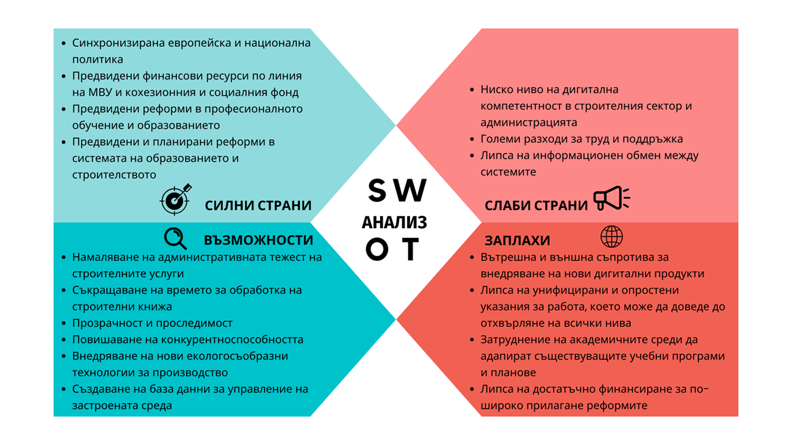
ANALYSIS
- Internal and external resistance to implementing new digital products
- Lack of unified and simplified work instructions, which can lead to rejection at all levels
- Difficulty for academics to adapt existing curricula and plans
- Lack of sufficient funding for wider implementation of the reforms
THREATS
- Reducing the administrative burden of construction services
- Reduction of time for processing construction documents
- Transparency and traceability
- Increasing competitiveness
- Implementation of new environmentally friendly production technologies
- Creation of a database for the management of the built environment
OPPORTUNITIES
WEAKNESSES
- Low level of digital competence in the construction sector and administration
- High labor and maintenance costs
- Lack of information exchange between systems
STRENGHTS
- Synchronized European and national politics
- Anticipated financial resources under the International Monetary Fund and the Cohesion and Social Fund
- Anticipated reforms in vocational training and education
- Anticipated and planned reforms in the system of education and construction
- Strengths: At the level of European policy and national priorities, there is no divergence. Regulatory guidelines and processes are synchronised, which is a prerequisite for reducing administrative barriers to the implementation of technological solutions and best practices from other member states. Necessary financial resources for digital transition are foreseen at the level of operational programmes as well as in the Recovery and Sustainability Mechanism (20% of funds should be used for digital transition), including vocational education and training through EU level organisations and initiatives - Digital Skills and Jobs Platform, FELM - vocational education and training. Education and construction reforms envisaged and planned.
- Weaknesses: low level of digital competence in the construction sector; high labour costs for experts in the administration, commitment to maintain specialized software products; costs for cloud technologies; low level of digitalization in municipal administrations and lack of competence to work with specialized construction software products; adaptation to existing systems - lack of information exchange between systems;
- Opportunities: reducing the administrative burden of construction services; shortening the time for processing documents; more transparency and traceability; building on existing knowledge and skills, and potential for progress; increasing the competitiveness of the Bulgarian construction industry in the context of the European market; introducing new environmentally friendly production technologies; promoting digitalization and innovation in the construction sector; creating databases for the management of the built environment.
- Threats: Internal (within the administration) and external (to employees in the sector) resistance to implementing new workflow products; Lack of unified and simplified guidelines for working with digital products, which can lead to rejection at all levels; Difficulty for academics to adapt existing curricula and programs into new digital products; Lack of sufficient funding for wider implementation of reforms.

The conclusions of the SWOT analysis are as follows:
1. Digitalization in the construction sector has its undeniable multiple benefits in terms of reducing administrative costs for design, construction document coordination, etc., increasing private sector productivity, improving construction quality and contributing to a greener, more environmentally friendly process, reducing CO2 footprint, reducing energy costs, etc.
2. The weaknesses identified can definitely be mitigated and corrected with appropriate and timely measures such as investment in training of staff and experts; publicity about the benefits of going digital, support from industry organizations in the construction sector to assist in the process of introducing e-services.
3. Undoubtedly, digitalization is the future not only in the construction sector, but also in all spheres of economic life and faster adaptation to the processes will lead to the adequacy of the industry to international markets.
4. The threats identified could slow down the process of introducing new digital technologies, which will have a negative effect at the level of EU policy implementation, as well as lead to sanctions for the country.
Overall, the SWOT analysis for the digitalization of the construction sector in Bulgaria shows that the European and national concept for further digitalization of processes in construction through the introduction of various systems and platforms in the public and private sector, as well as the resourcing of professionals who should use the software products has a positive outlook in economic, social and environmental terms. The strategy takes into account the weaknesses identified and provides mitigating measures for the most significant internal and external negative factors.

- SWOT ANALYSIS FOR THE INTRODUCTION OF BIM
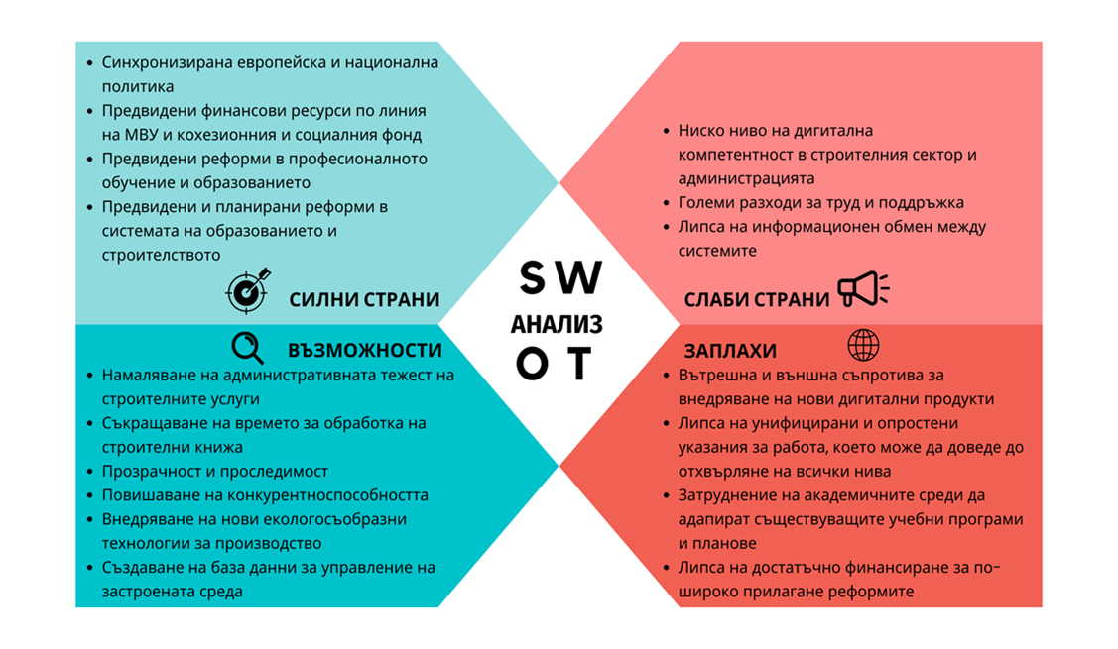
ANALYSIS
- Unavailability or delays / inconsistencies in the development of legal provisions and binding standards regarding BIM in Bulgaria
- Reluctance to change and low BIM demand
- Inability of academics to adapt existing curricula and plans
THREATS
WEAKNESSES
- High initial investment
- Lack of cooperation between project participants
- Lack of universal software platform and experts
- A large expenditure of labor for the development of a national BIM-model
- Specific shortcomings of the BIM in the different stages of the construction process
- Increased competitiveness of the Bulgarian construction sector
- Upgrading the available knowledge and skills of those working in the sector
- Promoting digitization and innovation in the construction sector
- Existing funding opportunities
OPPORTUNITIES
STRENGHTS
- Reduction of mistakes made in the construction-investment process
- Faster and more efficient documentation generation
- Better execution, management and control of projects
- Energy efficiency
- Greater value for money and encouraging innovation, etc.
The analysis identified the following advantages, disadvantages, opportunities and threats associated with the use of BIM:
- Strengths: Reduction of errors in the construction and investment process; Faster and more efficient generation of design and construction documents; Reduction of design and construction costs; Reduction of waste of construction materials; Better project execution, management and control; Energy efficiency; Better value for money (in public projects) and promotion of innovation; Greater transparency in the construction process; Greater productivity of public sector construction; Cost savings for taxpayers; Specific advantages of BIM in planning and design, in construction and in the operational stage of the construction site.
- Weaknesses: High initial investment; Lack of cooperation between project participants; Lack of a universal software platform; Contentious legal issues; Lack of experts; High labour cost for the development of a national BIM model; Low level of digitalisation in public administrative processes serving the construction sector; Specific shortcomings of BIM at different stages of the construction process.
- Opportunities: Increased competitiveness of the Bulgarian construction sector and the opportunity to participate in EU and other international projects, including the opportunity to be included in European smart cities and smart infrastructure projects; Upgrading the existing knowledge and skills of those working in the sector and the potential for advancement; Developing greater awareness among stakeholders; Mandatory public procurement with BIM in many countries; Large number of public projects; Adapting to a sustainable built environment; Encourages
- Threats: inaccessibility or delays/inconsistencies in the development of legal provisions and binding standards regarding BIM in Bulgaria; lack of qualified and experienced staff; reluctance to change and low demand for BIM; lack of necessary professional knowledge and experience for project management by procurers; inability of academia to adapt existing curricula and programmes or create new SIM programmes; lack of funding for wider implementation of BIM.

The conclusions of the SWOT analysis are as follows:
1. The introduction of BIM has its undeniable multiple benefits in terms of public resource use, increased private sector productivity, construction quality and its environmental footprint.
2. The identified weaknesses can definitely be mitigated and corrected with appropriate measures: use of EU funds to reduce the burden of initial investment and training of staff and experts; development of a national BIM model and a corresponding software platform to serve the approval and storage of investment projects developed through the BIM; increasing the level of digitalization in public administrative processes serving the construction sector by introducing e-services.
3. The introduction of BIM increases the sector's competence and significantly expands its market opportunities in Europe and worldwide; this policy ensures the development of innovation and the better quality of our lives.
4. The threats identified could slow down the process of introducing SIM, and the positive effects of its implementation, but would not deter the process or cause reversible actions.
Overall, the SWOT analysis of the introduction of BIM in Bulgaria shows that the government's concept of further digitalization of construction through the introduction of BIM in public projects has a positive outlook in both economic and social aspects. The strategy takes into account the weaknesses identified and provides mitigating measures for the most significant internal and external negative factors.

- DEVELOPMENT TRENDS OF THE CONSTRUCTION SECTOR IN BULGARIA
Based on the analyses, the following challenges have been identified for the construction sector to address:
- increasing productivity growth, (currently, last among EU Member States in terms of resource efficiency),
- reducing the number of bankruptcies in the sector and attracting a skilled and professional workforce,
- attracting young people to careers in construction and motivating the ageing workforce to learn new technologies in the sector,
- reducing administrative burdens,
- stimulating public spending on construction education, better cooperation between business and the education system to modernise curricula,
- increasing digital skills levels among adults, young people and ICT professionals;
- ensuring the availability and accessibility of information on the digitisation of the entire construction process and the application of BIM in public administrations, unification of digital design and electronic project submission formats, staff qualification;
- building centralised systems for information exchange in a Common Data Environment (CDE), electronic systems for administrative services; electronic cadastral maps,
- availability of guidelines and template documents for the use of electronic systems and BIM,
- lagging behind in terms of integration of digital technologies and the introduction of BIM Bulgaria,
- Active participation in the process of drafting a regulatory framework to define formats and standards for the development and digital approval of plans and projects as well as IT infrastructure,
- improving waste management processes and procedures, which continues to be a challenge for Bulgaria and is one of the main causes of poor air quality due to high concentrations of fine particulate matter.
Prerequisites for the transformation of the construction sector in Bulgaria
- the main priority of European and national policies is the development of digital technologies, their penetration in the construction sector and the use of their exceptional potential for increasing the competitiveness of the Bulgarian economy, strengthening the supply and efficiency of public services,
- numerous funding opportunities from EU funds and programmes for digitisation and reform of the construction sector,
- the existence of a national policy framework defining the Bulgarian government's vision for digital transformation as a necessary process of Bulgaria's technological development to create conditions for innovation and business growth, increased efficiency of the workforce, a competitive digital economy and high standards for citizens,
- the existence of a single European policy for the introduction of BIM as a means of increasing productivity and quality in the construction sector,
- demand for a skilled workforce with new skills and roles,
- despite the reduced interest in working in the construction sector, high-potential candidates are being attracted to jobs in the sector.
Taking into account the perspectives in the development of European policies, as well as the analysis of the current state of the construction sector, the Bulgarian government has developed the following vision, concrete steps, measures and objectives to solve the outlined problems in the construction sector and its future sustainable development:
- VISION
TRANSFORMING THE CONSTRUCTION SECTOR THROUGH A NEW GENERATION OF DIGITAL TECHNOLOGIES INTO A RESOURCE-EFFICIENT ECONOMIC SECTOR AND ENABLING THE DIGITISATION AND MANAGEMENT OF THE BUILT ENVIRONMENT TO MEET EUROPEAN AND NATIONAL ENVIRONMENTAL AND CLIMATE NEUTRALITY OBJECTIVES

The integration of digital technologies in construction is seen as a key element to address the main challenges facing the sector, such as labour shortages, competitiveness, resource and energy efficiency and productivity. Given that the construction sector is one of the main pillars of the national economy, addressing these challenges and its growth are of utmost importance, but the digital transformation of the sector also has its
larger and longer-term goal through digitisation and management of the built environment to contribute effectively to the implementation of European and national policies for a green, digital, sustainable ecosystem, digital economy, energy efficiency, circular economy, climate neutrality, sustainable use of resources, demographic change, attractive jobs, education, training.

This ambitious goal of digital transformation of the construction sector can be achieved with policies to advance and develop the sector in three main areas:
- IMPLEMENTATION OF DIGITAL TECHNOLOGIES
The digitisation of the construction sector includes data collection, process automation and other technologies related to digital information and analysis. Three categories of digital technologies are currently used in construction:
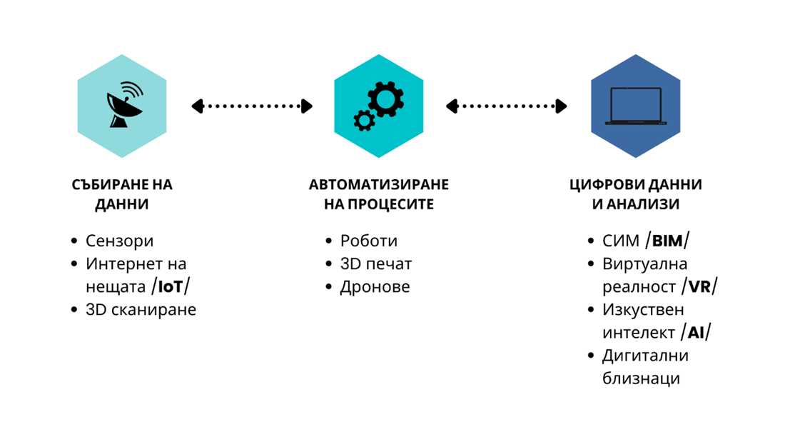
DIGITAL DATA AND ANALYSIS
- BIM
- Virtual reality /VR/
- AI
- Digital twins
AUTOMATION OF PROCESSES
- Robots
- 3D printing
- Drones
DATA COLLECTION
- Sensors
- Internet of Things /IoT/
- 3D scanning
Data collection technologies, namely sensors, IoT and 3D scanning, are the starting point for the digitisation of the construction sector as they provide most of the data needed to build and develop a digital construction ecosystem. In this area, sensors are the technology with the highest level of market maturity and technology readiness; however, significant improvements are required when integrating them into existing buildings. The growth in their use will enable economies of scale, increase their affordability and accelerate their deployment.
Process automation in the construction sector refers to the use of robots, 3D printing (additive manufacturing) and drones to automate specific activities in the construction sector. The benefits of their use include increased efficiency, greater precision, improved safety and security in the workplace.
These technologies are at different stages of development. Robotics and 3D printing are still in the development phase and have not been widely adopted in the construction sector except for very specific and limited tasks or in projects specifically designed for their use. At the same time, drones are increasingly being used, thanks to the development and improvement of the sensors with which they are equipped.
The effective use of digital data represents the future of the construction sector. Analysing data makes sense of its systematisation and provides tangible improvements and benefits in asset management. BIM is being used more and more in the construction sector due to the important benefits it brings - cost savings, better collaboration between stakeholders and improved project delivery. It is one of the recommended innovative technologies used in the construction sector, yet its application is often limited to the design phase of large projects. Virtual/Augmented Reality and Artificial Intelligence are in the development stage and are not considered ready for application. The development of digital twins is currently limited to a few pilot projects, but most public and private stakeholders consulted agree that they have great potential for the future.

- CREATION OF DATABASES
The European Data Strategy aims to make the EU a leader in a data-driven society. The creation of a single market for data will allow it to move freely within the EU and across sectors for the benefit of businesses, researchers and public administrations.
The digital transformation of the sector envisages the development of tools and a system for collecting and storing digital data on the existing and new built environment in order to manage it in line with environmental objectives, minimising risks to climate, human health and biodiversity:
- digitization of technical and energy passports of all physical assets (existing and new constructions);
- structuring of databases for the built environment by territorial-administrative and classification features;
- digitizing the map materials for defining the different impacts on the structures (risk maps, geological maps, tectonic maps, demographic maps, etc.);
- integration of the accumulated digital information into a single digital cadastre;
- connecting all databases in a common communication system;
- organization of a national database as an information model of the built environment, which unites regional, district, city, municipal databases;
- managing and using information to create smart buildings and places.

- DIGITAL TRANSFORMATION OF ENTERPRISES
The digital transformation of enterprises in the construction sector is another important direction of development of the sector. It is necessary for enterprises that: design and create the built environment; survey and photograph the existing built environment; maintain and manage the operation of physical assets; and manufacture construction products and structures.
Embedding technological capacity in enterprises will allow them to benefit from the potential of digital transformation and support the building of a healthier and greener society. Digital technologies, including 5G, the Internet of Things, peripheral computing, artificial intelligence, robotics and augmented reality will be more than enablers; they will be at the heart of new products, new production processes and new business models based on the fair sharing of data in the data economy.
The transformation of enterprises depends on their ability to rapidly and ubiquitously adopt new digital technologies. EU support, in particular through the Single Market and Digital Europe programmes and the Cohesion Programme, will promote the building and use of digital capacities, including data spaces, computing power, open standards, testing and experimentation facilities.
Businesses are encouraged to adopt digital technologies and products with a smaller environmental footprint and better energy and resource efficiency. Digital technologies need to be adopted quickly to create opportunities for more intensive and efficient use of resources. In this way, a sharp increase in material productivity will reduce production costs and vulnerability to supply shocks. Manufacturers will be able to improve preventive maintenance and produce to order, based on specific user needs, with zero inventory, thanks to digital twins, new materials and three-dimensional printing.
Particular attention should be paid to ultra-modern and revolutionary innovations. SMEs are central to this transition not only because they represent the vast majority of enterprises in the construction sector, but also because they are a critical source of innovation. SMEs should be able to easily access digital technologies or data on fair terms provided by regulation and be able to benefit from adequate support to go digital. In this respect, more than 200 digital innovation hubs and industry clusters located across the EU should support the digital transformation of both innovative and non-digitalised SMEs and connect digital providers to local ecosystems. The aim is to achieve a high level of digital intensity without leaving anyone behind.

- THE MAIN PREREQUISITE FOR THE DEVELOPMENT OF THE CONSTRUCTION SECTOR IN THE ABOVE THREE AREAS IS THE PRESENCE OF:
regulatory basis
The regulatory basis for the construction sector should stimulate the uptake of digital technologies, define the conditions and requirements for their use, remove barriers and ensure policy coherence.

Professionals with digital skills
Professionals in the construction sector should have access to digital training and education that provides the specialised digital skills they need to pursue quality jobs and satisfying careers, and lifelong learning should become a reality.

secure and resilient digital infrastructure
Digital infrastructure serving citizens, SMEs, the public sector and large enterprises needs high-performance computing infrastructure and a comprehensive data infrastructure.

digitisation of public services
E-services ensure accessibility, provide user-friendly, efficient and personalised services and tools with high standards of security and privacy protection, seamless interaction between advanced capabilities such as data processing, artificial intelligence and virtual reality. Their availability is driving businesses, and SMEs in particular, to become increasingly digital.
Taking into account the global long-term goal of digitisation of the construction sector, the guidelines defined at European level and the prerequisites for its development,
a National Strategy for Digital Transformation of the Construction Sector with a Horizon to 2030, was developed, which focuses on the short-term goal of creating the conditions for digital transformation of the construction sector, with a view to increasing its efficiency, competitiveness and sustainability and building a more attractive investment environment that provides equal opportunities for all, including gender equality.

It sets out two strategic objectives and how they will be achieved:
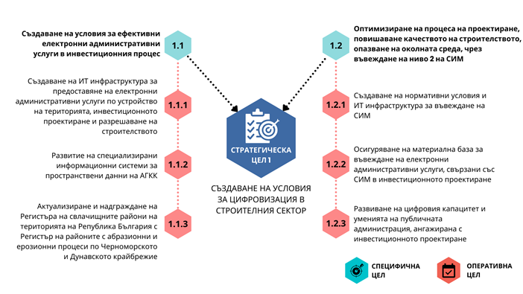
OPERATIONAL GOAL
SPECIFIC GOAL
CREATING THE CONDITIONS FOR DIGITALIZATION IN THE CONSTRUCTION SECTOR
STRATEGIC GOAL 1
Optimizing the design process, increasing the quality of construction, protecting the environment, by introducing level 2 of BIM
Creation of regulatory conditions and IT infrastructure for the introduction of BIM
Provision of a material base for the introduction of electronic administrative services related to BIM in investment planning
Developing the digital capacity and skills of public administration involved in investment design
Creation of conditions for effective electronic administrative services in the investment process
Creation of an IT infrastructure for the presentation of our electronic administrative services for territorial planning, investment design and construction authorization.
Development of specialized information systems for spatial data of the Agency for Geodesy, Cartography and Cadastre
Updating and upgrading the Register of landslide areas on the territory of the Republic of Bulgaria with the Register of areas with abrasion and erosion processes along the Black Sea and Danube coasts
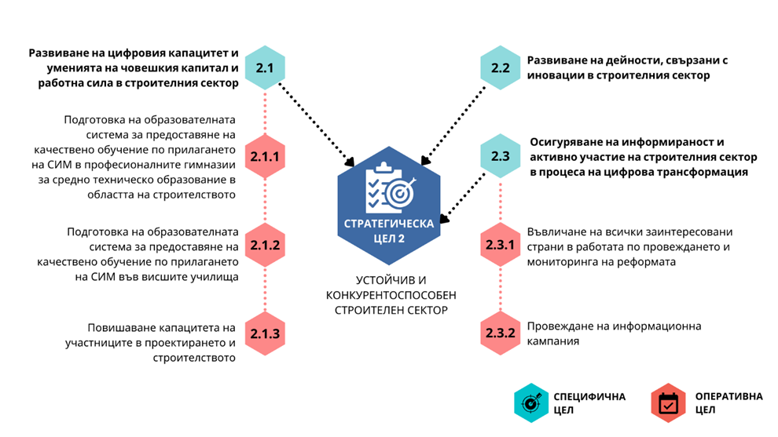
OPERATIONAL GOAL
SUSTAINABLE AND COMPETITIVE CONSTRUCTION SECTOR
STRATEGIC GOAL 2
SPECIFIC GOAL
Development of activities related to innovations in the construction sector
Ensuring awareness and active participation of the construction sector in the process of digital transformation
Involvement of all interested parties in the work on the implementation and monitoring of the reform
Conducting an information campaign
Developing the digital capacity and skills of the human capital and workforce in the construction sector
Preparation of the educational system to provide quality training in the application of SIM in vocational high schools for secondary technical education in the field of construction
Preparation of the educational system for the provision of quality training in the application of SIM in higher schools
Capacity building of participants in design and construction
As part of the national policy for technological development and digital transformation of the economy, this strategy is aimed at digital reform of the processes of development, coordination, approval of investment projects, permitting, execution and control of construction, improvement of administrative services. The strategy aims to create conditions for the implementation and phased introduction of building information modelling (BIM) requirements in public works procurement.
The envisaged reform is wide-ranging - it covers regulation, central and regional administrations, education, entrepreneurs and construction business, IT sector.
The implementation of the digital reform of the construction sector will lead to an increase in the quality and efficiency of the design and implementation processes of the construction works, will create opportunities for their better maintenance, prolongation of their life, better management of material assets and energy resources. The reform aims to modernise the conservative construction sector and attract young people to it, to increase their qualifications and competitiveness, to stimulate high-tech innovation in the sector, sustainable construction, to reduce its negative environmental footprint and to create favourable conditions for international investment.
The success of the strategy will bring obvious direct and indirect benefits to the construction business, the Bulgarian economy and society as a whole. This plan is expected to unlock the potential of the digital capacity of the construction industry and put the Bulgarian construction sector on a competitive level among its peers in the European Union.
In line with the panorama of policies developed by MS to stimulate the use of digital technologies in the construction sector, this strategy plans a Reform with a 2030 horizon, which foresees the provision of:
- regulatory conditions and IT infrastructure for digital transformation of the construction sector - formats for electronic transmission of construction documentation and infrastructure for its management, including storage of documentation and its systematization in registers, integration of information systems;
- electronic management of the procedures for filing, ex officio forwarding for intra- and inter-ministerial coordination, approval and delivery of the final administrative act related to draft spatial plans and investment projects;
- databases for spatial planning, investment design and construction permitting, cadastre and landslide, abrasion and erosion processes on the territory of the Republic of Bulgaria and their publication or electronic provision to third parties;
- opportunities to upskill public and private sector staff to work with BIM Level 2;
- the gradual transition to digital BIM Level 2 operation of public and private sector construction actors;
- conditions for the provision of quality education for the implementation of SIM in vocational secondary technical schools and higher education institutions in the field of construction;
- conditions for innovation in the construction sector.

The creation of regulatory conditions, IT infrastructure, digital platform, information systems and registers related to construction is the basis without which the digitisation of the sector cannot start. The existing regulatory framework does not specify formats and requirements for electronic submission of investment projects for approval. The requirements for signatures and stamps on construction documentation predetermine its paper-based format. The lack of regulations, infrastructure and systematic databases are the factors that deter the penetration of digital technologies in the construction sector.
The strategy envisages measures for the analysis and amendment of the regulatory framework, for the creation of IT infrastructure that will allow electronic management of procedures under the Spatial Planning Act (SPA) related to draft spatial plans and investment projects. The information systems will provide access to information, data and documentation, which will greatly facilitate both citizens and businesses and the administration itself.
The analysis and amendment of the regulatory framework foreseen in the strategy will be carried out with a view to establishing formats and requirements for construction documentation both for the purpose of implementing an electronic administrative service and for the purpose of introducing BIM.
Administrative e-services have a key role to play in facilitating the digitisation of construction processes and the uptake of digital technologies in the construction sector. A growing number of EU Member States are introducing e-services for building permits, registration and storage of digital passports and property registers. Geographical Information Systems (GIS) and registers with 3D asset models are gradually being developed. This is critical to support the transformation of the sector and its growth, as well as climate and sustainability goals.
This strategy provides for the establishment of a Unified Information System for spatial planning, investment design and construction permitting. By Decision No. 704 of the Council of Ministers dated 05.10.2018 (Measure No. 30 of Annex No. 1 - Measures to simplify and bring services for business in line with the Law on Limitation of Administrative Regulation and Administrative Control over Business Activities), the Ministry of Regional Development and Public Works (MRDPW) has been entrusted with the implementation of a measure for the creation of a unified information system to enable the regimes in the investment process to be administered entirely electronically.
The unified information system will be a platform for the provision of electronic administrative services in spatial planning, investment design and construction permitting. The ENI will enable electronic submission of documents, applications and projects, authorization of development and approval of spatial plans, approval of investment projects, issuance of construction and commissioning permits.
The unified system for spatial planning, investment design and construction permitting will manage the processes of conducting the procedures for application, official referral for inter-departmental and intra-departmental coordination, approval and delivery of the final administrative act and will provide the opportunity for electronic submission and approval of draft spatial plans and investment projects.
As a result of the establishment of the system it is envisaged that the applicant will submit a single request for the performance of the respective administrative service (provision of the respective package of services), intra- and inter-agency coordination will be carried out as an internal electronic administrative service, and finally the competent authority will issue and deliver the final act electronically. The system will include:
- all administrations that provide administrative services and issue administrative acts under the Spatial Planning Act - the Ministry of Regional Development and Public Works, 28 regional governors, 265 municipal administrations, 35 district administrations in cities with regional division, the Directorate for National Building Control;
- central and territorial administrations and specialized control bodies, which, under the Environmental Protection and Water Act, the Biodiversity Act, the Cultural Heritage Act, the Agricultural Land Protection Act, the Roads Act, the Health Act, the Marine Spaces, Inland Waterways and Ports Act of the Republic of Bulgaria, or any other special law, have the obligation to issue administrative acts or to carry out coordination as a prerequisite for the approval of spatial development plans, approve
- operating companies, which coordinate: assignments for the preparation of spatial development plans, proposals for amendments to detailed spatial development plans and draft spatial development plans and their amendments; provide source data with the design vision; coordinate investment projects; provide opinions for commissioning of completed works.
The system will automate not only intra-departmental, but also inter-departmental administrative process, and will make possible the provision of complex electronic administrative services. It is planned to integrate the Unified System for Spatial Planning, Investment Design and Construction Permitting with:
- A unified register for spatial planning, investment design and construction permitting, which will contain the final administrative acts of the administrative services performed under the SPA, in order to automatically include in the register, the acts, the product of the respective service. A repository is foreseen in the register, which will store the spatial plans approved by the respective final act and the approved investment projects to the issued construction permits, forming a digital “file” of the constructions, and will ensure their accessibility and publicity as the part on investment projects will be restricted to citizens. The repository will serve as a virtual unlimited archive of approved development plans, approved investment projects and technical passports, which is the legal obligation of every administration. Decision No. 546 of the Council of Ministers of 2019 adopted the Updated e-Government Development Strategy (2019-2023). In Annex No. 1 - Unification of registers and establishment of unified registers by thematic areas, the Strategy provides for Measure 3 on the establishment of a Unified Public Register on Spatial Planning, Investment Design and Construction Permitting, which will unify the registers maintained by the Ministry of Regional Development and Public Works, the National Construction Control Directorate, regional governors, municipal administrations and district administrations in cities with regional division. The establishment of the Single Public Register is also in line with measures 104 and 105 of Annex 3 “Abolition of Registers or Regulation of Registers Maintained without Regulatory Basis” of the Updated e-Government Development Strategy (2019-2023).
The implementation of the Unified Public Register on spatial planning, investment design and construction permitting will contribute to the implementation of the basic principle of one-time collection and creation of data, as well as their official electronic provision to third parties. The establishment of an information system for its service is envisaged. The register will provide access to information and documentation necessary for the provision of administrative services, i.e. it will create conditions for the provision of internal administrative services, which will significantly facilitate both citizens and businesses and the administration itself.
- Spatial Planning Portal. The implementation of a Spatial Planning Portal is another measure of the strategy. The portal is foreseen to be established by § 50 of the Transitional and Final Provisions to the Law on Amendment and Supplement to the SPA (promulgated in SG No. 25 of 2019).
The portal will be a central, public, web-based GIS information system that provides for the publication of draft spatial plans, their amendments and the spatial plans that have entered into force. It is planned to be integrated and to build on the Cadastral-Administrative Information System (CAIS) of the Geodesy, Cartography and Cadastre Agency. The Territorial Spatial Planning Portal will visualise information from the cadastral map and cadastral registers and on the provisions of the adopted current general spatial plans and detailed spatial plans (spatial data), ensuring publicity and information. In addition to the current services and inquiries made on the cadastral map and cadastral registers, the portal will also allow inquiries on the foresight of the general spatial plans and detailed spatial plans.
The development of the specialized spatial data information systems of the Geodesy, Cartography and Cadastre Agency is also planned. The measure is aimed at developing all spatial data information systems and related services of the Geodesy, Cartography and Cadastre Agency to integrate them into a new information system for cadastral and specialised data and to achieve high sustainability, transparency and interoperability, as well as ensuring integrations with primary registers and e-government systems. This activity also includes upgrading the functionalities of the cadastral information system for integration with external systems, both for automated exchange through the RegiX inter-registry exchange system and for the provision and reception of open-format spatial data network services.
- The Single Information Point established under the Electronic Communications Networks and Physical Infrastructure Act (ECNPIA) in accordance with Directive 2014/61. This integration will enable operators of electronic communications networks to electronically submit applications to the competent authorities (local and others) responsible for granting/refusing the necessary authorisations for the deployment of electronic communications networks. It will facilitate the provision of information to the applicant on the progress of the process and on the relevant decision issued by the competent authority(ies). The competence for granting authorisations remains unchanged (i.e. at central/regional/local level), but the process will be ensured as far as possible by digital means. This will bring significant improvements to the process of building new digital infrastructures as it will reduce the administrative burden that usually slows down telecom operators. On the other hand, the proposed solution is in line with best practice in many Member States where authorisations are granted by individual local authorities. The integration will create the conditions for the functioning of a so-called single access point, leaving to the individual administrations (central or local) the power to manage and decide on the authorisation.
The integration of the registry, the portal and the system is as follows:
- the system administers electronically the process of creation, coordination and approval of spatial plans and investment projects, issuance of building permits and certificates of commissioning of completed buildings under the terms and conditions of the SPA - from the submission of an application for an administrative service to the issuance of the final act for its implementation;
- the above final act is published in the established register thanks to the integration of register and system;
- the approved spatial development plan is reflected in the Spatial Development Portal, which provides a visualisation of the site-specific planning.
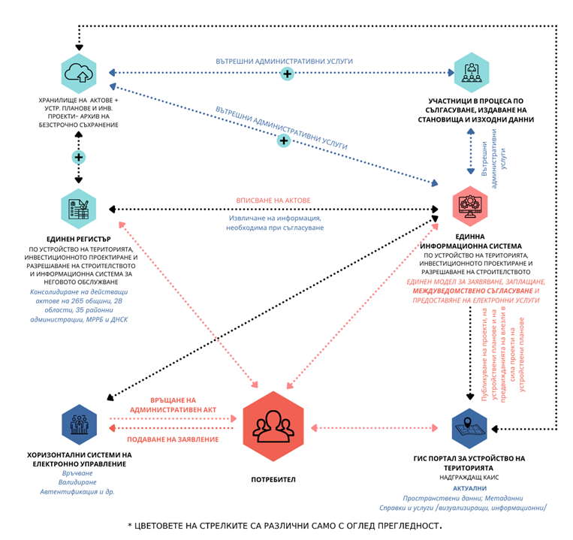
* Arrow colors are different for clarity only
GIS portal for territorial planning
Upgrading KAIS
Current
Spatial data; Metadata
References and services /visualization, information/
USER
Horizontal electronic control systems
Delivery
Validation
Authentication etc.
Submitting an application
Return of an administrative act
Publication of projects, development plans and forecasts of implemented development plan projects
Unified information system
for territorial planning, investment design and construction authorization.
A single module for application, payment, interdepartmental coordination and provision of electronic services
Internal administrative services
Participants in the reconciliation process, issuing opinions, source data
A unified register
of territorial planning, investment design and construction authorization, and an information system for its service.
Consolidation of current acts of 265 municipalities, 28 regions, 35 regional administrations, MRDPW and Directorate for National Construction Control
Repository of acts + development plans and investment projects - archive of indefinite storage
Retrieving information needed for reconciliation
REGISTRATION OF DEEDS
INTERNAL ADMINISTRATIVE SERVICES
INTERNAL ADMINISTRATIVE SERVICES

The introduction of electronic administrative services in spatial planning, investment design and construction permitting will ease the administrative burden on citizens and businesses by significantly reducing the technological time for the provision of services in the sector of spatial planning, investment design and commissioning of completed construction and will create opportunities for the provision of complex electronic administrative services. As a result, it will improve the country's position in terms of investment conditions and improve the business environment.
Another important area of digitisation is the creation of registers and databases. Some of these are necessary for the introduction of BIM, while others serve to facilitate the work of the public and private construction sectors, to collect data needed for process automation and other technologies related to digital information and analysis.
The MRDPW carries out a complex of activities related to the improvement of the territory, registration and monitoring of landslide areas on the territory of the Republic of Bulgaria.
The Strategy provides for activities related to the registration and monitoring of landslide areas on the territory of the Republic of Bulgaria, of abrasion processes on the Black Sea coast and of erosion processes on the Danube coast, as well as the prevention of urban areas threatened or affected by them. By taking specific measures, the MRDPW aims to ensure the possibility of drawing up reports from the Register of landslide areas and areas with abrasion and erosion processes on the Black Sea and Danube coasts by districts, municipalities, settlements, by active, potential and stabilized landslides, by groups, classes, categories of landslides according to Regulation No. 12 on the design of geo-protective structures, buildings and facilities in landslide areas and other indicators. The system will be expanded to provide a unified GIS platform for registration, input, visualization, sharing and use of geographic data and applications. The registry will be integrated with the cadastral map and GIS of the MRDPW to allow easier identification of land affected by landslide processes.
The system will maintain the developed registers with monitoring information, engineering-geological reports, photos, video files and other data related to the registered sites, will provide up-to-date and correct information and will provide public and specialized access to the available geospatial data in compliance with the security and protection requirements of WEB-oriented systems.
In the water and sewerage sector, a project was implemented: “Supporting efficiency, management and institutional capacity in the water and sewerage sector”, with the financial support of the Operational Programme “Environment 2014-2020” under Grant Agreement No. D-34-11/16.03.2016, within the framework of which a Unified Information System for water and sewerage services and a register of plumbing associations and plumbing operators (ENI for plumbing) was designed and developed, in accordance with the requirements of Art. 198r of the Water Act.
The unified information system for water and sewerage services and the register of water and sewerage associations and operators will provide access to a large volume of up-to-date information on the development of water supply and sanitation in the Republic of Bulgaria, on the main indicators of the quality of water and sewerage services provided, their prices, the approved business plans for the activities of water and sewerage operators, water and sewerage associations, planned investments in water and sewerage infrastructure and their implementation, areas with deviations in drinking water quality indicators, etc. The system is based on modern geo-information server technology, with data integration capabilities and report and analysis generation in tabular and graphical formats.
In the framework of the same project, an Information System for Water Management Systems and Facilities (IS for WMSF) was designed and developed in accordance with the requirements of Art. (1) (2) of the Water Act. The WSSI accumulates data on critical water management facilities - dams, reservoirs, irrigation systems, reservoirs, pumping and treatment plants, water supply and sewerage networks and facilities, etc. The IS for the WMSF is to maintain up-to-date information on the type, location, ownership, rights granted for management, maintenance and operation, technical parameters, etc. of water management systems and facilities on the territory of the Republic of Bulgaria in the three sectors - water supply and sewerage, hydraulic reclamation and hydropower. The aim is to provide an efficient data structure for water management systems and facilities, based on modern geo-information server technology, with possibilities for data integration and generation of reports and analyses in tabular and graphical format. The IS for the WMSF will allow tracking the performance of the systems based on the basic hydraulic parameters set for them.
The IS for the WMSF maintains basic and specialized data, including data on the administrative-territorial division of the territory of the Republic of Bulgaria, provided by the Geodesy, Cartography and Cadastre Agency, on population by the NSI, on water bodies (rivers, lakes, dams, underground water bodies) and protected areas by the MoEW, on transport infrastructure by the RIA and National Railway Infrastructure Company, which are provided through the implemented integration with the ENI of the water and sewerage services.
The introduction of BIM and the requirement to use the technology when procuring construction through public procurement is a specific focus of policies that contribute to promoting digitalisation in the construction sector. Many national governments have introduced BIM requirements in their procurement processes. Feedback from both industry and public sector actors indicates that this is particularly useful in promoting the digitisation of the construction sector.
To implement this policy, the Bulgarian government has adopted a participatory approach in which the public sector takes the lead in defining and guiding strategy and objectives. Stakeholders are responsible for achieving the objectives themselves. The MRDPW and other public bodies are also actors in this process, driving aspects that fall within their remit - technical rules, procurement, and the gradual introduction of BIM requirements in public procurement, in line with stakeholder readiness.
The strategy includes three phases for the introduction of BIM Level 2, preceded by a preparatory period of capacity building. During this period, the regulatory framework will be prepared, the national BIM model will be developed, the necessary IT structures, guidelines and procedures for BIM implementation, training programmes. This period is seen as a capacity building phase for BIM, which will in fact continue in practice beyond 2026 until the mass implementation of BIM in Bulgaria.
After the 2023-2026 BIM capacity building period, BIM will be phased into procurement activities. The phased approach will enable the various stakeholders to be trained, prepared and equipped with the necessary tools to implement digital technology.
The phase marking the introduction of BIM in public procurement activities is expected to start in late 2026/early 2027 with the introduction of a requirement to use BIM in public procurement for works worth more than €50 million. The obligation will only be for these works, but will not preclude the procurement of BIM technology for lower value works.
The second phase of BIM implementation is expected to start at the beginning of 2030. The scope of this stage will be public works contracts worth more than EUR 20 million.
Prior to the introduction of a requirement to use BIM in public procurement, an analysis will be carried out on the scope of stages in relation to building construction projects, according to specific criteria and thresholds.
The start of the third phase is foreseen in 2033. Its scope will be determined after analysis and study of the results of the implementation of the first two phases of the BIM strategy. The analysis will cover the readiness of the sector to implement the BIM, the quality of implementation of the sites, the capacity developed and the benefits achieved against the targets set. Based on the results of this assessment, the scope of the next phase of BIM implementation will be determined.
Building information modelling will cover the entire life cycle of the construction: planning/investment studies, design, creation of digital databases on the characteristics of construction products, 3D models of the construction, construction, electronic passports of buildings and facilities and their respective databases, management of the operating costs of the construction, their repairs, renovations and demolition. The technology will optimize the design process and data structuring, reduce the cost of construction products, increase the attractiveness and competitiveness of the sector and create conditions for attracting foreign investment.
The full impact of the introduction of BIM is expected to be seen in the mass deployment of BIM Level 3, known as integrated BIM. This level of technology is considered to be the next generation of BIM processes, the form of which has not yet been sufficiently defined and developed. The introduction of Level 3 BIM is part of the long-term objectives of the strategy.
The 10-year horizon of the strategy aims at the introduction of level 2 of BIM. This level of BIM is the best achievement of digital technology in construction to date. At Level 2, the concept of collaboration ensures a complete and seamless implementation of investment projects. All project components are represented in a three-dimensional environment. The project has clearly distinguishable data in a common environment (DCE) in which all stakeholders share documents, engineering networks, 3D structural and architectural elements within the BIM model and work collaboratively. All disciplines develop a unified BIM project that enables coordination, clash checking and constructability studies.

DEFINITIONS AND COMPONENTS OF BIM:
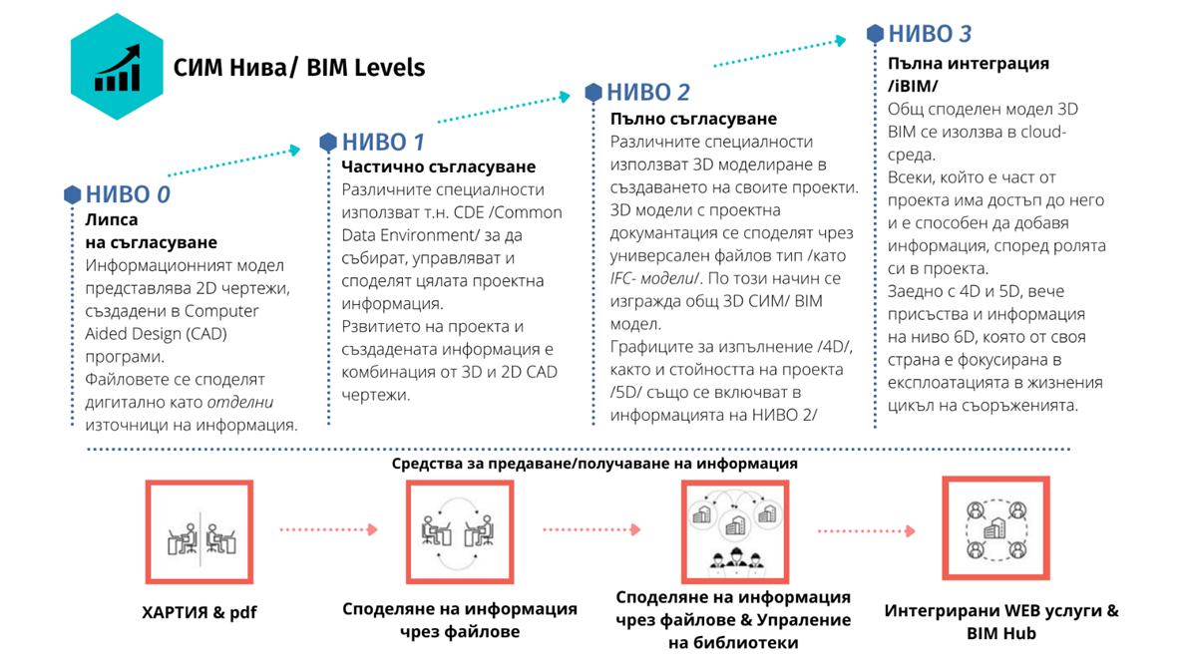
Integrated WEB services and BIM Hub
Share information through files and Manage libraries
Share information through files
Paper and pdf
Means of transmitting / receiving information
LEVEL 3
Full integration /iBIM/
A common shared 3D BIM model is used in a cloud environment.
Everyone who is part of the project has access to it and is able to add information according to their role in the project.
Along with 4D and 5D, there is now also information at the 6D level, which in turn is focused on operation in the life cycle of facilities.
LEVEL 2
Full agreement
Different specialties use 3D modeling in the creation of their projects. 3D models with project documentation are shared via a universal file type /such as IFC-models/. In this way, a general 3D BIM model is built.
Implementation schedules /4D/ as well as project cost /5D/ are also included in Level 2 information.
LEVEL 1
Partial agreement
Different specialties use the so-called CDE / Common Data Environment/ to collect, manage and share all project information.
The development of the project and the information created is a combination of 3D and 2D CAD drawings.
LEVEL 0
Lack of agreement
The information model represents 2D drawings created in Computer Aided Design (CAD) programs.
Files are shared digitally as individual sources of information.

For this purpose, a software infrastructure will be created to work with BIM projects in the process of approval and coordination of investment projects. It is envisaged to develop a module to the Unified Information System set out in Operational Objective 1.1.1, hosted on the State Hybrid Private Cloud (SHPC), with the ability to submit BIM projects for approval and provide access to them by contractors and inspection bodies during construction, as well as owners of commissioned works.
In order to remove administrative and regulatory barriers to the implementation of effective electronic administrative services in the investment process, a focus on hardware and software provision of experts from municipal, regional and state administration and improving the qualification of the administration approving investment projects is necessary.
For this purpose, technical support is foreseen for the provision of software with an open license for reviewing and working with BIM projects, the purchase of hardware to ensure the functioning of the software in the administrations and the provision of 300 workstations in 28 regional administrations, 28 large municipalities and 3 ministries (MRDPW, MoI and MoC). The envisaged administrations are involved in the approval process of investment projects and will be selected in view of the higher likelihood of the implementation of large public works contracts requiring BIM, linked to the first stage of the introduction of the obligation to apply BIM in public design and construction contracts.
Enhancing competence, capacity and knowledge is another prerequisite for pushing the reform path. The development of requirements for the use of BIM in public procurement, as well as the approval of investment projects developed through BIM, requires specific capacity building from the public sector as well as from the private sector (small and large players) that will benefit from the opportunities of digitisation.
To improve the qualification of the approval and coordination bodies, specialised training is provided for the specialists from the municipal, regional and state administration, as well as for all coordination bodies involved in the approval of investment projects and the issuance of building permits.
It is envisaged that the experts from the administration for whom jobs are provided will build capacity and acquire fundamental knowledge in:
- BIM basics;
- the methodology, basic processes and workflows when working with BIM;
- contractual obligations and responsibilities when using BIM;
- all parts of ISO 19650 and NM BIM;
- working with open-source software to view, mark and track changes for BIM models, conforming to the European Commission's recommended IFC format and focused on the relevant specifics of the approval and reconciliation tasks;
- knowledge required to develop EIRs (information exchange requirements) and review/audit BIM models and associated data gaps against EIR requirements.
The training will also be prepared in online format for distance learning of experts from the private business (consultants, operating companies, etc.) involved in the coordination and approval of investment projects. The online format of the training will be made available to the Institute of Public Administration for subsequent training of staff from all interested administrations, as well as published on a developed web-based platform for self-learning of the coordination bodies outside the state and municipal administration, in order to ensure sustainability over time and increase the scope of competence in the construction sector.
The reform will lead to an increase in the qualification of the administration, the efficiency of public administration and the quality of public services in the construction sector. The MRDPW envisages the preparation and material provision of 300 administrative experts to work on the coordination and approval of investment projects.
Human capital capacity building is a key prerequisite for the success of the strategy implementation. Knowledge transfer and education related to the implementation of BIM are clearly embedded in Specific Strategic Objective 2.1 Develop the digital capacity and skills of the human capital and workforce in the construction sector. The MRDPW foresees the preparation of guides and online self-training materials for designers, builders, consultants and companies involved in the coordination of investment projects. The materials, will be published on a web-based platform the MRDPW developed for this purpose.
The measures foreseen for “logistical support” and capacity building of SMEs as well as coordinating bodies outside the state and municipal administrations foresee the creation of explanatory/training materials prepared by the software developers as well as contracted out to be prepared by public procurement regarding open source software programmes.
Participants in the construction process should build capacity and knowledge to:
- BIM concepts, standards and protocols such as BS EN ISO 19650 and PAS 1192 “Specification for Information Management in the Handover Phase of Construction Projects Using BIM”;
- BIM levels and scope;
- Interoperability and common data exchange formats such as IFC and COBie;
- 3D BIM technologies such as laser scanning tools, imaging and point cloud computing solutions;
- Collaboration platforms and workflows for BIM, such as data in a common environment and design coordination solutions;
- Solutions for coordinating BIM-based projects and workflows such as scheduling, scope management, cost/budget control, and quality control;
- BIM requirements for handover of projects and facilities and applications in the operational phase, such as asset management, facilities management (FM), operations & maintenance (O&M), and geographic information systems (GIS).
Branch organizations will stimulate the process of training of practicing architects and civil engineers for the application of BIM technologies by organizing information and practical courses, seminars and trainings. In 2021, they set up a non-profit association, the European Digital Innovation Hub for Construction, to support micro, small and medium-sized enterprises, the public sector and society in the digital transformation of the construction industry. The initiative of the Chamber of Builders in Bulgaria united the efforts, expert capacity and potential of the branch organizations - CCB and Chamber of Architects in Bulgaria, universities in the field of construction and scientific institutions - University of Architecture, Construction and Geodesy, Higher School of Construction “Lyuben Karavelov”, Institute of Mechanics - BAS and leading organizations and companies from the private sector specialized in construction, project management, technology and innovation in the face of CleanTech Bulgaria Ltd, Geostroy AD, Planex Ltd, Bulgarian Association for Project Management in Construction (BAPMC), Baumit Ltd and Esri Bulgaria Ltd.
The European Digital Innovation Hub (EDIH) has prepared a project that has successfully passed the national selection process and in June 2022 was approved for funding under the European Commission's European Digital Innovation Hubs procedure under the Digital Europe 2021-2027 Programme as “DIGITAL-2021-EDIH-01” with complementary funding under the “Research, Innovation and Digitalisation Programme for Intelligent Transformation” (RIDPIT) for the 2021-2027 programme period. The project has a duration of 3 years (with the possibility to upgrade for another 4 years) and starts in the fourth quarter of 2022.
EDIH will support the implementation of the Strategy under the Digital Europe project by providing access to training, workshops and consultancy on BIM to micro, small and medium enterprises in the sector to enhance the capacity of designers and construction professionals.
The systematic training of participants in design and construction will also be supported by the chambers of architects, engineers and builders. Each year the chambers will prepare plans and organise seminars and training for their members.
The strategy provides logistical support for SMEs in the form of a web-based platform with published online training, an interactive guide (manual) to the national BIM model, design and approval processes for BIM projects, downloadable resources such as libraries, templates and forms, and digital maturity checker applications for enterprises in the construction sector.
The strategy envisages reforming formal secondary and tertiary construction education by creating conditions for the provision of quality education for the implementation of BIM in vocational secondary technical schools and tertiary institutions in the field of construction.
The need to develop professional educators and leaders to lead capacity building initiatives for BIM among academic and professional stakeholders in the construction sector, as well as to raise their awareness, is outlined. It is anticipated that a period of about 5 years is required for academic institutions to reform their higher education curricula and respond effectively to the government's strategy to introduce BIM in investment design and the digitisation of the construction sector. In this period, HSs will prepare qualified teachers with excellent skills in the field of BIM technology, processes, procedures, standards and related regulations; innovate and prepare new academic programs for the Master's degree in management and various functions of the actors practicing BIM technology and provide the necessary facilities for this purpose.
As a first step, the HSs envisage assigning a limited number of prominent faculty members from each department to learn in detail about current practices in the field of BIM and the established national requirements for its implementation, and then to design training courses for the remaining faculty members. The first group of trainers will need external (probably foreign) courses and licenses for specialized software from different manufacturers.
In order to implement the updated curricula, it will be necessary for all teachers in the affected disciplines and specialties to reach a certain level of competence in the field of BIM. For some of them BIM is a familiar subject, for others it will be necessary to undergo in-service training.
The integration of BIM will affect a number of curricula, where some courses will need to be redesigned to include or emphasize the use of specialized professional software for BIM in the relevant subject area, as well as additional classes to introduce students to the principles of BIM and the national requirements for its implementation.
Most HSs have computer labs, but not all meet the requirements of modern BIM software. It is necessary to provide funds for their renovation. Partnership with business is a possible source of support in terms of equipping the classrooms, given the existing practice of branding them by the companies that have equipped them.
Academic training will provide prepared for the application of BIM personnel in the construction sector and will attract many young people to the profession. HSs will also organise training for practitioners in the construction sector.
The training of personnel in the construction sector should also cover secondary specialised education in the country. The Ministry of Education and Science is committed to the training of qualified teachers, training programmes for vocational school students in the sector, and the provision of the necessary software and hardware for training.
Measures related to the implementation of policies in vocational education and training, including in the construction sector, are contained in financial instruments with a justified source of funding:
- The national programmes for the development of education financed with funds from the state budget: the National Programmes “Vocational Education and Training”, “IT Skills and Career Training”, “Business Teaches” and “Motivated Teachers and Qualifications”, approved by Decision of the Council of Ministers No. 302 of 13 May 2022;
- The draft National Recovery and Resilience Plan (NRRP) and the Education 2021-2027 Programme (EP), which foresees the establishment of 24 Centres of Excellence for Vocational Education and Training through an integrated approach. The NRRP foresees the renovation, refurbishment and equipment of these centres, while the EP foresees the implementation of “soft” measures related to the continuing training of teachers and lecturers in partnership with business, the development of teaching documentation, the application of innovative teaching and learning methods, etc.
The sectoral approach is at the heart of the vocational education and training policies implemented by the Ministry of Education and Science. In order to adapt vocational education and training to labour market dynamics, including in the construction sector, the establishment of Sector Skills Councils (SSCs) is envisaged. The importance of the construction sector for the long-term and successful socio-economic development of the country has been explored in the framework of the above-mentioned approach. Based on its application, the MoES justified one of the pilot SSCs to be in the construction sector.
An essential element of the SSC is interaction with business. For the construction sector it will be based on building sustainable partnerships with chambers, associations, unions and universities. Under the Education Programme's Modernising Vocational Education and Training operation, there will be a comprehensive update of curricula, syllabuses and national examination programmes with sector councils at the centre. Teachers are also planned to be trained to carry out the necessary training according to the current labour market requirements and to transform vocational education and training in line with the requirements of digitalization and green technologies.
The reform focuses on the development of scientific potential and innovation in the construction sector.
The European Digital Innovation Hub for Construction has a key role to play in connecting science, practice and business in the process of transforming the construction sector.
The aim of EDIH in the construction sector is to support micro, small and medium enterprises, the public sector and society in the process of digital transformation of the construction industry. By virtue of the association's founding act and statutes, EDIH aims to become the main instrument to support the sector in the implementation of digital solutions and practices and to assist all actors in the process by providing specialised information, training, access to finance and expertise.
EDIH will start its activities supported by the Digital Europe Programme with additional co-funding provided by the “Research, Innovation and Digitalisation for Smart Transformation Programme” for the programming period 2021-2027. The project has a duration of 3 years (with the possibility to upgrade for another 4 years) and starts in the fourth quarter of 2022 or early 2023.
In line with the framework and requirements of the Digital Europe programme, the association will stimulate research and provide opportunities for pilot testing of experimental equipment, digital and technological solutions, innovations and materials. EDIH will support and participate in the creation of innovation networks, platforms and shared infrastructures for the exchange of knowledge and experience at national and international level, as well as ensure collaboration with partner organisations and stimulate networking. The association will promote the benefits of digital transformation for the construction industry and the processes for the implementation of the SIM; provide information on tools and mechanisms for the management and financing of small and medium-sized businesses under international and national programmes to facilitate the digital transition, European practices, and the introduction of new standards in this area.
Industry, scientific and sectoral organisations, as well as those focused on the digitisation of the sector and the application of BIM in the design, construction and operation of construction works, can, individually or through alliances, establish centres for training, consultancy, technology transfer, database management, and innovation in relation to the introduction of BIM in the construction sector.
The strategy foresees the implementation of 2 pilot investment projects for implementation through BIM technology, procured through public procurement - design and implementation of a road section of the national road network and a building. The selection of a pilot investment project for a building shall be carried out according to the financing possibilities for its implementation of a specific municipality or of the National Association of Municipalities in the Republic of Bulgaria in cooperation with the branch organizations in the field of spatial planning, investment design and construction.
The development of the National Strategy for Digital Transformation of the Construction Sector is part of the reform set out in the National Recovery and Resilience Plan 2022-2026 (NRRP). Its implementation will be supported by the following planned investments, funded through the NRRP, the OPGG and through the state budget:

1. Establishment of a “Unified Public Register of Spatial Planning, Investment Design and Construction Permitting and an Information System for its Service”, financed under the OPGG.
2. Establishment of a “Unified Information System for Spatial Planning, Investment Design and Construction Permitting”, funded under the NRRP.
3. A portal on spatial planning, provided for by § 50 of the Transitional and Final Provisions to the Act on Amendment and Supplement to the Act on Spatial Planning (Journal of Laws No. 25 of 2019). The project will be financed from the state budget.
4. Project “Development of the specialized information systems for spatial data of the Geodesy, Cartography and Cadastre Agency”. The funding is from the state budget.
5. Project “Updating and upgrading of the Register of landslide areas on the territory of the Republic of Bulgaria and of the areas with abrasion and erosion processes on the Black Sea and Danube coasts”, financed from the budget of the MRDPW.
6. “Support of a pilot phase for the introduction of Building Information Modelling (BIM) in the investment design and construction as a basis for digital reform of the construction sector in Bulgaria" The project is funded by the NRRP.
7. The national programmes for the development of education financed with funds from the state budget: the National Programmes “Vocational Education and Training”, “IT Skills and Career Training”, “Business Teaches” and “Motivated Teachers and Qualifications”, approved by Decision of the Council of Ministers No 302 of 13 May 2022;
8. The projects of the National Recovery and Resilience Plan (NRRP) and the Education Programme 2021-2027 (EP), which foresee the establishment of 24 Centres of Excellence for Vocational Education and Training through an integrated approach. The NREAP foresees the renovation, refurbishment and equipping of these centres, while the EP foresees the implementation of “soft” measures related to the continuing training of teachers and lecturers in partnership with business, the development of teaching documentation, the application of innovative teaching and learning methods, etc.
9. Project “DIGITAL-2021-EDIH-01” under the “Digital Europe 2021-2027” programme with complementary funding under the “Research, Innovation and Digitalisation for Smart Transformation Programme”.

- PRINCIPLES FOR IMPLEMENTING THE STRATEGY
The following sector-specific principles have been applied in developing this strategy:
- Principle of partnership
The principle of partnership has been applied with broad consultation of all institutions - state and local authorities, business, NGOs, all stakeholders, including in ensuring gender equality economic and social partners.
In connection with the introduction of BIM Level 2, the Minister of Regional Development and Public Works by his Order No. RD-02-14-165_20.02.2020 established a National Working Group (NWG) for the introduction of BIM for the entire life cycle of construction works. The main tasks of the NWG were advisory and expert functions for the development of a draft Long-Term Strategy for the introduction of the BIM in the design, implementation and maintenance of construction works, as well as an Action Plan for the implementation of the Long-Term Strategy, through which to organize and plan its implementation, monitoring, evaluation and the need for updating, defining the operational objectives for each strategic objective, the activities for their implementation, the deadlines for implementation, the expected results, the performance indicators, the necessary resources, funding sources and responsible institutions.
Representatives of all stakeholders were identified as appropriate partners for the development of the strategy and invited to participate in the NWG: representatives of the MRDPW, the National Association of Municipalities in the Republic of Bulgaria, the Chamber of Engineers in Investment Design, the Chamber of Architects in Bulgaria, the Chamber of Builders in Bulgaria, the Bulgarian Association of Architects and Consulting Engineers, the Bulgarian Institute for Standardization, the University of Architecture, Civil Engineering and Geodesy - Sofia, the Technical University – Sofia, Lyuben Karavelov Higher School of Construction, Varna Free University “Chernorizets Hrabar”, Todor Kableshkov Higher School of Transport, National Association of Construction Entrepreneurs, Ministry of Education and Science, Scientific and Technical Union for Construction in Bulgaria, Public Procurement Agency, Road Infrastructure Agency and Nemetschek Bulgaria.
For the implementation of the tasks, the NWG is working together with the implementation team of the REFORM/SC2020/089 project “Preparation and launch of digital reform of the Bulgarian construction sector”, funded under the Structural Reform Support Programme 2017-2020 of the European Union. The project Steering Committee (SC) included representatives of the European Commission, the Ministry of Finance, the Ministry of Economy and the Ministry of Transport and Communications.
All project outputs were consulted with the representatives of the NWG and the SC and comments, observations and recommendations received were provided to the project implementers for their reflection.
In developing this strategy, a working draft was circulated to both the representatives of the NWGs and the institutions they represent for comments and additions to objectives and measures. By Order No. RD-02-14-1010/24.10.2022 of the Minister of Regional Development and Public Works, a new NWG was established to develop this strategy and a roadmap for its implementation with broad representation of all the above identified stakeholders.
The partnership is linked to three objectives: the precise definition of the objectives of the programme actions, their effective implementation and the enhancement of the sector's development capacity. In this respect, the strategy foresees that its monitoring, control and reporting will be carried out by the NWG under the leadership of the Ministry of Regional Development and Public Works, which includes representatives of all stakeholders.

- Principle of additionality
The principle of additionality provides for EU funds to be complemented by national funding sources, the level of which is determined by the country. This principle has been applied in the planning of investments accompanying the reform.
The planned investments will be financed by both the NRRP and OPGG funds and the state budget. The activities of the established European Digital Innovation Hub in the construction sector “DIGITAL-2021-EDIH-01” will be funded under the European Commission's Digital Europe 2021-2027 procedure with complementary funding under the “Research, Innovation and Digitalisation for Smart Transformation Programme”.

- Principle of transparency
The basic presumption of providing operational and institutional information on transparency is an essential condition for the free and open exchange of information with stakeholders, where the rules and rationale for policies and practices are fair and clear to all.
Access to information and material resources, and the opportunity for different groups to participate in public interest decision-making has been realised in the process of developing this strategy and is guaranteed to be realised in its implementation.
To monitor, control and report on the measures included in the strategy, transparent procedures are foreseen by the NWG of stakeholders, which include open meetings and sessions, public reporting on budget spending, access to public information, auditing, etc.
High ethical standards, transparency and accountability in the public sector are prerequisites for good governance and sustainable development. In this context, the National Strategy for Digital Transformation of the Construction Sector has been published for public consultation.

- Principle of openness and security
One of the main objectives of the reform is to facilitate construction processes by ensuring accessibility to public data that is not subject to restrictions for security, privilege or privacy reasons. The reform will ensure that data is made available as quickly as possible, and that its timeliness and value are preserved. The information systems to be implemented will be accessible to a wide range of users for a wide range of purposes.
At the same time, the main priority in the design and construction of information systems will be to ensure their security, adequate anticipation of threats, possible affected areas in the event of a breach of the various protection mechanisms and the implementation of effective and efficient mechanisms for the prevention and tracking of breaches in information systems.
The problems of information security and information protection in management systems will be set out to be solved at the design stage. A sufficient degree of security, confidentiality and protection of data and information will be ensured in the future operation of the information environment in compliance with the following principles:
- convenience for users;
- each user is provided with only the privileges they need;
- simplicity and economy of the information system without compromising its efficiency;
- verification of credentials to access protected information.
Adequate management of ICT and security risks will be required of staff with the necessary skills to support their operational needs and management processes, development and implementation of information security policies, procedures and plans aligned with current legislation, available international standards and generally accepted best practices.

- STRATEGIC OBJECTIVES:

Strategic objective 1: Creating conditions for digitisation of the construction sector

Specific strategic objective 1.1: Creating conditions for effective electronic administrative services in the investment process

Operational objective 1.1.1: Establishing the regulatory conditions and IT infrastructure for the provision of electronic administrative services in spatial planning, investment design and construction permitting.
Measures:
- Establishment of a unified register for spatial planning, investment design and construction permitting;
- Establishment of a Unified Information System for spatial planning, investment design and construction permitting;
- Development of draft amendments to related laws and regulations, including new regulations created for the functioning of the systems.
Integration of the above systems with information systems and registers of other administrations, with the developed horizontal modules of e-government: e-Authentication, e-Granting, e-Authorisation; e-Payment and with the environment for inter-register exchange (RegiX).
- Digitization of existing spatial plans and integration into a common spatial database of the Unified Register

Operational objective 1.1.2: Development of the specialised spatial data information systems of the Geodesy, Cartography and Cadastre Agency
Measures:
- Creating a new single, unified, optimized centralized cadastral architecture and information system;
- New, improved (streamlined, simplified and shortened) work processes for the provision of administrative and electronic administrative services, in line with the integrated administrative service and the principles of the e-Government Act, aimed at users, including by amending and streamlining specialised legislation, internal rules, procedures, etc.;
- Revised model and implementation of the information and communication environment in order to improve the quality, speed and reliability of the cadastral administrative services provided by the Geodesy, Cartography and Cadastre Agency system and to achieve interoperability, while complying with the requirements set out in the Electronic Management Act (EMA);
- Integration with information systems and registers of other administrations, with the developed horizontal modules of e-government: e-Authentication, e-Granting, e-Authorization; e-Payment and with the environment for inter-register exchange (RegiX).
- Establishment of a Spatial Planning Portal;

Operational Objective 1.1.3: Update and upgrade the Register of Landslide Areas on the Territory of the Republic of Bulgaria with a Register of Areas with Abrasion and Erosion Processes on the Black Sea and Danube Coasts
Measures:
- Development of new modules, update and optimization of existing applications of the Landslide Register and integration of all components of the GIS of the MRDPW.
- Implementation and regular operation of the new functionalities of the Landslide Register.

Specific strategic objective 1.2: Optimising the design process, improve the quality of construction, protect the environment by introducing level 2 of BIM in investment design and construction

Operational objective 1.2.1: Establish the regulatory conditions and IT infrastructure for the introduction of SIMs
Measures:
- Analysis and development of a legislative framework;
- Development of a national BIM model, templates and procedures for information collection, management and sharing, security and access control based on BDS EN ISO 19650 and CEN standards;
- Development of libraries of BIM objects to reflect construction products and materials in infrastructure construction;
- Establishment of software infrastructure for working with BIM projects in the process of approval and coordination of investment projects;
- Introduction of requirements for the application of BIM in public procurement
- Analysis of BIM implementation and sector readiness with a view to scoping the procurement of third stage construction works for BIM implementation.

Operational objective 1.2.2: Provide facilities for the introduction of electronic administrative services related to BIM in investment design.
Measures:
- Hardware and software support for experts from municipal, regional and state administration involved in the process of coordination and approval of investment projects;
- Development of a web-based platform with published online training, an interactive guide (manual) to the national BIM model, design and approval processes for BIM projects, downloadable resources such as libraries, templates and forms, and digital maturity checker applications for businesses in the construction sector;
- Pilot development of a module for automated checking for conflicts between all engineering networks, structural and architectural elements within the BIM model and for automated reconciliation

Operational objective 1.2.3: Develop the digital capacity and skills of public administration involved in investment design
Measures:
- Conducting specialized trainings in line with the common framework standards for the introduction of BIM and European best practices in administration;
- Preparation of an online training format for further training of staff from all interested administrations through the Institute of Public Administration;
- Conducting annual training of experts from public administrations.

Strategic objective 2: A sustainable and competitive construction sector

Specific strategic objective 2.1: Develop the digital capacity and skills of the human capital and workforce in the construction sector

Operational objective 2.1.1: Prepare the education system to provide quality training in the application of BIM in vocational schools for secondary technical education in the field of construction
Measures:
- Specialized training of teachers in vocational schools preparing personnel for the construction sector to work with BIM;
- Updating the state educational standards for the construction professions, curricula and syllabuses to ensure skills in working with BIM software;
- Provision of the necessary hardware and software for training in vocational schools in the field of construction;

Operational Objective 2.1.2: Prepare the education system to provide quality training on the implementation of BIM in HSs
Measures:
- Preparation of teachers from all necessary specialties in the HSs;
- Development and introduction of curricula for the application of BIM and their inclusion in the curricula for the training of all architectural and engineering staff in HSs;
- Provision of the necessary hardware and software to conduct the training at the HSs;

Operational objective 2.1.3: Enhancing the capacity of design and construction actors
Measures:
- Development of manuals for planners and for the administration approving investment projects;
- Creation of online training materials for the use of open access BIM design software for businesses;
- Developing annual plans and organising seminars and training for architects, engineers and builders from the chambers, including sharing best practices and challenges overcome;
- Organizing and conducting specialized trainings, conferences, lectures, seminars and consultations aimed at capacity building on topics related to the introduction of digital technologies in construction processes by the EDIH.

Specific strategic objective 2.2: Developing innovation-related activities in the construction sector
Measures:
- Providing access to specialised research infrastructure and expertise for pilot testing of experimental equipment, innovative products, digital and technological solutions, materials and services to accelerate their commercialisation
- Providing information on tools and mechanisms for managing and financing small and medium-sized businesses through international and national programmes and initiatives for pilot testing of digital technologies and the implementation of innovative projects.
- Supporting access to partner organisations, the creation of innovation platforms, shared infrastructures and stimulating networking.
- Defining themes and areas of collaboration between science and business with a focus on the digitisation of the construction process and providing a database of research projects with potential for commercialisation
- Preparation and procurement of pilot projects for implementation through BIM technology - infrastructure project and building project

Specific strategic objective 2.3: Ensure awareness and active participation of the construction sector in the digital transformation process

Operational objective 2.3.1: Involve all stakeholders in the preparation and implementation of the reform
Measures:
- Functioning of an NWG of representatives of all stakeholders to monitor the implementation of the strategy;

Operational objective 2.3.2: Conduct an information campaign
Measures:
- Conducting a survey of stakeholders' communication needs and attitudes and run a media campaign;
- Holding press conferences in the 6 planning regions in Bulgaria;

- EXPECTED RESULTS BY STRATEGIC OBJECTIVES
Result: Strategic objective 1: Create the conditions for digitalization of the construction sector
- Established IT infrastructure for provision of electronic administrative services in spatial planning, investment design and construction permitting
- Functioning Single Registry and Single Information System;
- Integrated Unified Information System with the Unified Register of Spatial Planning, Investment Design and Construction Permitting, the Spatial Planning Portal and the Single Information Point established under the ECNPIA, respectively Directive 2014/61;
- Integration of the above systems with information systems and registers of other administrations, with developed horizontal modules of e-government: e-Authentication, e-Granting, e-Authorization; e-Payment and with an environment for inter-register exchange (RegiX).
- Digitised spatial plans in force, integrated into a common spatial database of the Single Registry;
- Drafted amendments to related laws and regulations, including new regulations for the functioning of the systems.

- Functioning unified, streamlined and centralized cadastral information system;
- Shortened and simplified work processes for the provision of user-oriented administrative and e-administrative services, in line with the integrated administrative service and the principles of the e-Government Act;
- Implemented an information and communication environment with improved quality, speed and reliability of the cadastral administrative services provided by the Geodesy, Cartography and Cadastre Agency system and ensured interoperability in accordance with the SPA;
- Integration with information systems and registers of other administrations, with developed horizontal modules of e-government: e-Authentication, e-Granting, e-Authorization; e-Payment and with an environment for inter-register exchange (RegiX);
- Established Portal on spatial planning.

- Updated and upgraded Register of landslide areas on the territory of the Republic of Bulgaria and of areas with abrasion and erosion processes along the Black Sea and Danube coasts;
- Developed new modules, updated and optimized applications of the Landslide Register and integration of all GIS components of the MRDPW;
- New functionalities of the Landslide Register implemented and put into operation;
- Optimized integration of data from Geopreservation companies;
- Implemented mobile application for field data collection;
- Search, Feedback and Forum modules developed;
- Updated map services in the system;
- Built an application to share data from partner organizations;
- Updated user interface;

- Provided regulatory conditions and IT infrastructure for the introduction of BIM through:
- Legislative framework ensuring the application of BIM in public works procurement;
- Developed a national BIM model and guidelines for information collection, management and sharing, security and access control;
- Developed libraries of BIM objects to reflect construction products and materials in infrastructure construction;
- Established software infrastructure for working with BIM projects in the process of approval and coordination of investment projects and plans;
- Introduced requirements for the application of BIM in public procurement;
- Analysis prepared with proposal for scope of Stage 3 to introduce BIM in public works procurement.

- Provided facilities for the introduction of electronic administrative services related to BIM in investment design.
- 300 jobs created for experts from municipal, regional and state administration involved in the process of coordination and approval of investment projects;
- A functioning web-based platform with published online training, an interactive guide (manual) to the national BIM model, design and approval processes for BIM projects, downloadable resources such as libraries, templates and forms, and digital maturity checker applications for businesses in the construction sector;
- Developed module for automated checking for conflicts between all engineering networks, structural and architectural elements within the BIM model.

- Trained 300 experts from the administration of 28 regional administrations, 28 large municipalities and 3 ministries (MRDPW, MoI and MoC) to implement the reform in the construction sector and created an opportunity to enhance the capacity of design and construction actors in the private sector and administration through:
- Conducted specialised trainings in line with the common framework standards for the introduction of BIM and European best practices to 300 experts from the administration;
- Online trainings prepared for follow-up training of all interested administrations, provided to the Institute of Public Administration and published on a web-based platform;
- Public administration experts trained annually.

Result: Strategic Objective 2: Sustainable and competitive construction sector

- Provided quality training in the application of BIM in vocational schools for secondary technical education in the field of construction through:
- 70 teachers in vocational high schools preparing personnel for the construction sector qualified to work with BIM;
- Updated state educational standards for construction professions, curricula and syllabi to ensure skills in working with BIM software;
- Hardware and software provided for training in at least 4 vocational schools in the field of construction

- Provided quality training on the implementation of BIM in HSs through:
- Prepared teaching staff;
- Introduced BIM implementation programs for all architecture and engineering majors in HSs;
- Provided hardware and software to conduct the training;
- Provided annual internships and placements for students in construction business organizations Hardware and software to conduct the training

- Opportunities created to enhance the capacity of design and construction actors:
- Manuals developed for planners and the administration approving investment projects;
- Created and published on a web-based platform with published online training, an interactive guide (manual) on the national BIM model, design and approval processes for BIM projects, downloadable resources such as libraries, templates and forms, and digital maturity checker applications for businesses in the construction sector;
- Seminars and trainings held; number of specialists trained/year.

- A functioning Digital Innovation Hub for construction in Bulgaria;
- Access to specialised research infrastructure and expertise;
- Number of SMEs informed and consulted on management and financing instruments and mechanisms;
- Provided access to partner organisations, created innovation platforms, shared infrastructures;
- Planned research and development activities in the field of construction;
- Procurement of 2 pilot investment projects for implementation through BIM technology.

- Active involvement of all stakeholders in the preparation and implementation of the reform
- Functioning NWG, monitoring of strategy implementation.

- Increased stakeholder awareness of the digitalisation of the construction sector
- Media campaigns to promote the construction sector reform strategy;
- Press conferences held in the 6 planning regions in Bulgaria.

- FUNDING
Funding for the activities will be provided from different sources depending on the institutions responsible for implementing the relevant measures in the Action Plan. Funds will be provided from the state budget through the budgets of the institutions responsible for implementing the strategy, through the budgets of the NGOs responsible for implementing measures and/or through national programmes.
Key is the ability to leverage existing and future financing instruments to support the transition of the construction ecosystem.
The National Recovery and Resilience Plan (NRRP), agreed with the EU in response to the pandemic crisis, has been an important source of funding, partly in the form of grants and partly in the form of low-interest loans.
The Technical Support Instrument (TSI) supports Member States in a wide range of reform areas in each phase of reform: from design to implementation and evaluation, including efforts to reform construction policies, including the introduction of BIM.
The Digital Europe programme aims to shape the digital transformation of European society and economy, bringing benefits to all, but in particular to small and medium-sized enterprises. The programme supports the creation of industrial data spaces, allowing different industrial ecosystems, including construction, to benefit from the great potential of new data-driven business models. It supports the skills development of workers through in-depth digital skills courses as well as digital innovation hubs, which are key to the digital transformation of SMEs.
The InvestEU programme will trigger a new wave of investment using a guarantee from the EU budget. All four windows of the programme: Research, Innovation and Digitalisation; Small and Medium Enterprises; Social Investment and Skills and especially Sustainable Infrastructure will have a direct impact on supporting the construction ecosystem, especially the last one dedicated to funding projects in sustainable energy, digital connectivity, transport, circular economy, water, waste, other environmental infrastructure, etc.
EU funding instruments for upskilling and reskilling - Employment, Social Affairs & Inclusion - European Commission (europa.eu)
Erasmus+ 2021-2027 has a strong focus on social inclusion, the green and digital transition and promoting young people's participation in democratic life. It supports the priorities and actions identified in the European Education Area, the Digital Education Action Plan and the European Skills Agenda.
Cohesion Policy 2021-2027 - Regional Policy - European Commission (europa.eu) supports actions related to skills development in priority areas of smart specialisation strategies, to increase SME competitiveness and job creation in SMEs, ICT deployment in SMEs, including supporting infrastructures and services (digital innovation centres, living labs, etc.).
The Good Governance Operational Programme is the main instrument of the Republic of Bulgaria for the implementation of the administrative and judicial reform, including the introduction of e-government. The Good Governance Operational Programme has been developed in partnership between all stakeholders from the administration, the judiciary and the civil sector.
Cross-border cooperation programmes in which Bulgaria participates for the programming period 2021-2027:
Interreg VI-A Bulgaria-Serbia 2021-2027 Programme - the programme will support activities related to digitalization in two areas - under Priority 1 “Competitive Border Region” to increase the competitiveness and export potential of SMEs; as well as under Priority 2 “Integrated Development of the Border Region”, which will be implemented through the Territorial Strategy, measures for the development of skills for smart specialization, industrial transition, entrepreneurship and adaptability of enterprises are to be funded.
Interreg VI-A Bulgaria-Turkey 2021-2027 Programme - within the framework of Priority 2 “Integrated development of the cross-border region” of the programme, which will be implemented through a Territorial Strategy, a specific objective related to increasing the level of digitalization and climate neutrality of the local economy is included.
Interreg VI-A Romania-Bulgaria 2021-2027 Programme - within Priority 3 “A more inclusive cross-border region” of the programme, a specific objective related to Improving equal access to inclusive and quality services in education, training and lifelong learning is included. Part of the supported activities will include investments in learning facilities with a focus on digitisation: equipment, tools, etc.
Interreg VI-A Greece-Bulgaria 2021-2027 Programme - within Priority 2 “A more inclusive cross-border region” of the programme, a specific objective related to Improving equal access to inclusive and quality services in education, training and lifelong learning is included. The activities will focus on SMEs to improve skills and increase digital competences.

- PERFORMANCE MONITORING AND REPORTING
In order to achieve the objectives of the strategy, a Roadmap for the implementation of the actions has been developed in a time-bound manner, indicating the institutions, funding sources and expected results.
Monitoring, control and reporting is carried out by the NWG under the leadership of the Ministry of Regional Development and Public Works, which includes representatives of the MRDPW, the National Association of Municipalities in the Republic of Bulgaria, the Chamber of Engineers in Investment Design, the Chamber of Architects in Bulgaria, the Chamber of Builders in Bulgaria, the Bulgarian Association of Architects and Consulting Engineers, the Bulgarian Institute for Standardization, the University of Architecture, Civil Engineering and Geodesy, the Technical University of Sofia, Lyuben Karavelov Higher School of Construction, Varna Free University “Chernorizets Hrabar”, Todor Kableshkov Higher School of Transport, National Association of Construction Entrepreneurs, Ministry of e-Government, Ministry of Education and Science, Scientific and Technical Union of Construction in Bulgaria, Road Infrastructure Agency, etc. business representatives.
The tasks of the NWG are:
1. Coordination of the implementation of the Strategy and the Roadmap;
2. Analysis on the scope of the stages for the introduction of BIM in public procurement for building projects in 2026 and 2029.
3. Update of the Strategy and Roadmap in 2029;
4. Analysis of BIM application and sector readiness for its use with a view to scoping the procurement of construction works for the third phase of BIM deployment in 2033.
5. Preparation of monitoring reports to determine the extent to which the objectives have been met and to report on the implementation of the Roadmap to the Minister of the RDPW and the MC following the analyses under items 2 and 4;
6. Planned analyses and updates of the Strategy and Roadmap;
The NWG conducts in-person meetings at least once a year for interim reporting on the degree of achievement of objectives, with ongoing monitoring through electronic coordination and communication.
The first planned stages for the introduction of BIM in public procurement foresee thresholds for very high value works, suggesting that the obligation will only cover infrastructure works. The obligation introduced will not prevent the award of contracts for the implementation of BIM technology also for lower value works. At the insistence of the Chamber of Architects as a stakeholder, the NWG will discuss and analyse the possibility of including building projects according to specific criteria and thresholds in the obligation before introducing a requirement to use BIM in public procurement.
The start of the third stage for the introduction of BIM in public procurement is foreseen in 2033. Its scope will be determined after analysis and study of the results of the implementation of the first two phases of the BIM strategy.
As the current National Strategy for Digital Transformation of the Construction Sector has a horizon up to 2030 and focuses on the short-term goal of creating the conditions for digital transformation of the construction sector, it will need to be periodically updated and complemented with new measures until the long-term goal of digitalization and management of the built environment is met in order to effectively implement the European policies on green, digital, sustainable ecosystem, digital economy, energy efficiency, circular economy, net neutrality and sustainable development.

- CONCLUSION
The cooperation and partnership of all directly involved institutions at national, regional and local level with representatives of professional chambers in the construction sector and NGOs is essential for the implementation and achievement of the priorities set out in the National Strategy for Digital Reform of the Construction Sector. The commitment and active participation of all stakeholders in the drafting, implementation, monitoring and evaluation phases of the strategic and specific objectives is key to the effectiveness, efficiency, impact and sustainability of government policy. The draft of this Strategy is adopted by decision of the Council of Ministers as an expression of the Government's priorities for the strategic development of the country.
Despite the serious challenges faced by the public and private sectors, the efforts made by all are being justified by the expected results:
- meeting the needs of the target groups by ensuring that sectors of administrative services, which due to their specific and complex nature are extremely underrepresented in the field of e-services, can provide complex and synchronised e-services;
- ensuring interoperability for the transition to automated exchange of data and electronic documents, which contribute to the development of e-government as a basis for the modernization of public administration and optimization of administrative service processes for citizens and businesses.
- sustainable digital activities, optimised timelines, reduced costs;
- digital infrastructure for document, information and permissions storage established;
- increased transparency and productivity of digitally traceable workflows with time stamps, verification and validation;
- interoperability of data, systems and workflows among construction sector actors;
- improved quality, consistency and execution of documentation (technical passports, permits, visas, GIS integration, etc.)
- minimised administrative formalities and environmentally friendly activities within public operations;
- increased private sector confidence in public operations;
- increased efficiency of civil servants by introducing digital work processes and tools;
- cooperation and structured interaction between the public and private sectors;
- effective adoption and use of digital workflows by procurers to build public assets;
The implementation of the digital reform of the construction sector will lead to an increase in the quality and efficiency of the design, approval and execution processes, to the creation of opportunities for their better maintenance, prolongation of their life and better management of energy resources. The administration will provide integrated and synchronised e-services by ensuring interoperability and automated exchange of data and electronic documents.
The reform aims to modernise the conservative construction sector and attract the interest of young people to it, to increase their qualifications and competitiveness, to stimulate high-tech innovation in the sector, sustainable construction, to reduce its negative environmental footprint and to create favourable conditions for international investment and the business environment in the construction sector.

ANNEX: Roadmap for the implementation of the Strategy

Аз, долуподписаният преводач Галя Петрова Пейчева, гарантирам, че този документ е пълен, верен и точен превод от английски на български език на приложения оригинален документ на английски език.
Преводът се състои от 69 (шестдесет и девет) страници.
Преводач: Галя Петрова Пейчева

https://ec.europa.eu/info/strategy/priorities-2019-2024/europe-fit-digital-age/europes-digital-decade-digital-targets-2030_bg
https://eur-lex.europa.eu/legal-content/EN/TXT/?qid=1593073685620&uri=CELEX%3A52020DC0066
https://eur-lex.europa.eu/legal-content/EN/TXT/?uri=CELEX:52021DC0118(01)&qid=1677485594734
The data is based on an analysis produced by the European Construction Sector Observatory (ECSO) https://ec.europa.eu/growth/sectors/construction/observatory/country-fact-sheets/bulgaria_en
It is estimated that 275,000 new jobs could be created in the sector by 2020. CEDEFOP's 2010 Skills, Demand and Supply publication, p. 96 - http://www.cedefop.europa.eu/en/Files/3052_en.pdf.
COM(2011) 885/2.
COM(2012) 433.
European construction industry federation
Source: NSI, Employed persons and employment rates - national level; statistical regions; areas
Used data analytical report developed under the project “Sustainable employment and prevention of labor turnover”, financed under the Operational Program “Development of human resources”, co-financed by the European Union through the European Social Fund. The project is implemented by the Bulgarian Chamber of Commerce and Industry (BCCI), in partnership with the Confederation of Labor “Podkrepa” and the Confederation of Independent Trade Unions in Bulgaria (CITUB).”
https://www.fiec.eu/priorities/vocational-training-and-education
https://digital-strategy.ec.europa.eu/en/library/staff-working-document-data-spaces
European Path to the Digital Decade https://eur-lex.europa.eu/legal-content/EN/TXT/?uri=CELEX:52021DC0118(01)&qid=1677485594734

